ADVISE ON THE STRATEGIC APPROACH FOR THE SET-UP, LICENSING AND SUPERVISION OF THE CAPITAL MARKET INFRASTRUCTURE WITH FOCUS ON EXCHANGES: Recommendations report

29th April 2019

INDEX
1. EXECUTIVE SUMMARY 4
2. PRELIMINARY RECOMMENDATIONS 6
2.1. CONSOLIDATION, OWNERSHIP AND GOVERNANCE OF THE EXISTING TRADING FACILITIES 6
2.1.1. Consolidation of market infrastructures 6
2.2. BUSINESS, FUNCTIONAL AND TECHNICAL REQUIREMENTS FOR THE TRADING LAYER 11
2.2.1. Business requirements 11
2.2.1.1. Authorisation requirements 11
2.2.1.2. Capital requirements 14
2.2.1.3. Organisational requirements 16
2.2.1.4. Management body requirements 20
2.2.1.5. Corporate governance for stock exchanges 22
2.2.1.6. Internal rules and conflicts of interest 23
2.2.2. Technical requirements 25
2.2.2.1. IT Software recommendations 25
2.2.2.2. Infrastructure recommendations 27
(a) Physical measures 27
(b) Logical measures and other relevant issues 28
2.2.2.3. Communication recommendations for exchanges 29
2.2.2.4. Capacity and resilience recommendations 30
2.3. LISTING OF FINANCIAL INSTRUMENTS 31
2.3.1. Admission of financial instruments to trading 31
2.3.2. Issuance of foreign companies in Ukrainian Exchanges 32
2.3.3. Creation of a specific market or segment for international securities 33
2.4. TRADING REQUIREMENTS INCLUDING THE METHODS FOR PRICE FORMATION 35
2.4.1. Recommendations regarding the market model 35
2.4.2. Recommendations on trading mechanisms to increase market concentration an improve the price formation process 41
2.5. OPERATIONAL REQUIREMENTS TO IMPROVE THE TRANSPARENCY REGIME FOR ISSUERS 44
2.6. PRE AND POST TRADE TRANSPARENCY REQUIREMENTS 47
2.6.1. Recommendations on pre-trade transparency for organised markets 49
2.6.2. Recommendations on post trade transparency for organised markets 53
2.6.3. Recommendations on post trade transparency for OTC transactions 56
2.6.4. Consolidation of post-trade information 57
2.6.5. Recommendations on post-trade information for market members 58
2.7. MARKET ABUSE PREVENTION 59
3. BIBLIOGRAPHY 62
4. BME CONSOLIDATION process 63
4.1. Steps of the consolidation process 63
4.2. BME listing 66
4.3. BME’S STRUCTURE TODAY 67
4.4. BME’s Business model 68
4.5. Holding organization 71

- EXECUTIVE SUMMARY
This report provides a set of recommendations to the NSSMC based on the findings described in the Assessment report. These recommendations will foster the modernisation, consolidation and development of the trading infrastructure of the Ukrainian Capital market, so that it can align with European regulation and international best practices.
This report is organised in different sections according to the main issues to be considered in relation to the development of the Ukrainian market. Each section includes a set of explained recommendations in a number of issues, from transparency requirements, ownership structure and upgraded corporate governance, to technical and operational requirements for exchanges.
The first section provides some recommendations for the consolidation of the market infrastructure. More concretely, focusing on a consolidation of the trading layer, the recommendations focus on the creation of a company set up to manage a multi-market trading system that is equally own by existing exchanges to concentrate liquidity and obtain a single order book for Ukrainian securities.
The second section provides a number of recommendations to improve the business, functional and technical requirements for the trading layer. From the business point of view, our recommendations aim at improving the ownership and governance structure of the existing trading venues, by establishing new requirements of information in the authorisation procedure that enables the NSSMC to have a greater supervisory control on the legal, operational and technical structure of the market operators. In line with this, there are some recommendations on capital requirements, setting some estimates that could be used as reference for the calculation of the minimum resources that need to be allocated to ensure proper functioning. Furthermore, this section also provides organizational recommendations, such as a well-defined risk management policy, suitable market rules and management body requirements, including corporate governance policies that market operator should implement, manage and report to ensure consistency with international best practices. Lastly, the section describes the minimum technical requirements that are in line with international best practices. These recommendations deal with infrastructure issues (physical requirements, security measures, software standards…), communication standards, as well as some requirements the trading software should meet.
The third section focuses on listing related issues: recommendations on the admission of financial instruments to trading, the creation a new figure of counsellor to promote potential issuers to become listed in the Ukrainian market, recommendations for the listing of foreign companies in the Ukrainian markets and trading of international securities in Ukrainian market in similar way to BME’s Latin American blue chips market LATIBEX.
The fourth section deals with the trading requirements including the methods for price formation and includes our recommendations on the trading mechanisms based on auctions that we believe would suit better in an environment that is currently fragmented and not very liquid.
The fifth section provides a set of recommendations to improve the transparency obligations of issuers to provide higher market efficiency and security, in the light of a current regulation to a great extent already in line with European standards. In this regard, there is a need of action from the NSSMC to develop further detailed regulation and to implement supervisory tools to watch and enforce issuers’ compliance with information disclosure obligations. The information must be effectively disclosed and available to the general public in a cost effective way.
The next section covers pre and post transparency requirements and recommends the NSSMC to regulate in a more detailed way a set of pre-trade transparency obligations for stock exchanges and brokers operating OTC and post trade transparency obligations, highlighting the need to consolidate this information in a Consolidated Tape Provider.
Last section covers some market abuse recommendations.

- PRELIMINARY RECOMMENDATIONS
  - CONSOLIDATION, OWNERSHIP AND GOVERNANCE OF THE EXISTING TRADING FACILITIES
    - Consolidation of market infrastructures
According to BME’s experience, we recommend a financial market structure focused on the concentration of liquidity, centralisation of services and resources, orientation to clients and improvement of products and services. This structure will help the Ukrainian capital market to gain international visibility, market discipline and, in the event of a public listing, a fair valuation through the market, making international investment attractive.
We recommend a phased process according to the following main milestones:
- Concentration of liquidity through the interconnection along the asset types of the existing trading venues (exchanges).
Single
Trading
System
UX
Other trading venues
PFTS
Perspectiva

This step will require the implementation of a single multi-market trading system (STS), to which every trading venue will connect, with a single order book and, thus, a single price for every financial instrument.
From a legal perspective, this should be achieved through the incorporation of a new company.
There are two possible approaches to this process:

- Setting up a company to manage the STS. This can be achieved through a simultaneous foundation procedure, that is, with no IPO involved. The initial capital should be fully subscribed and paid in by the incumbent exchanges, in proportions to be decided, ideally coequal.
This company’s main activity would be the management and operation of the trading system, as well as the market supervision. As a by-product, the company can profit from the market data (quotes, prices, volumes…) or manufacturing indices to be used as underlying to financial derivative contracts.
Members of the founding exchanges would be entitled to trade in the STS.
In order to avoid any possible mismatch with existing legislation, the creation of this company and its activity could be provided in the Law of the Securities Market. The provisions should set the foundation, the governance structure, the main activity, the exclusivity of trading of the listed instruments, and the procedure to allocate those trades between members of different exchanges.
Other substantial provisions could be included to foster the market development, such as mandatory settlement in NBU/NDU/SC.
The NSSMC can play an important role by encouraging the existing stock exchanges to create this company with a single platform.

- Setting up an interconnection system with no managing company. This system should be based upon a mutual agreement between the incumbent exchanges. This agreement should provide for the procedure to list in a single order book a set of common instruments, as well as the market supervision.
The operation, management and commercial exploitation of any activity other than trading, such as market data, indices, etc. should be agreed aside.
Members of the founding exchanges would be entitled to trade in the STS.
Allocation of trades should also be agreed in those cases where the buyer and seller are members of different exchanges.
This option gives more leeway to the incumbent exchanges to manage the process, but it is uncertain that the final outcome is sufficiently in line with the objectives set by the NSSMC. At the same time, because it does not count on the cover of the Securities Markets Law, the resulting activity could show some incompatibility with the current legislation.
In the short term, this will allow the existing exchanges to continue operation and to preserve their own client base. In a first phase, this should dodge any potential resistance to corporate changes (mergers or takeovers). These existing exchanges will be, in practice, entry points to the single order book.
With the STS, the Ukrainian market will be seen as a single market, making it easier to access, for both domestic and foreign investors.
The market structure would look like the following figure:
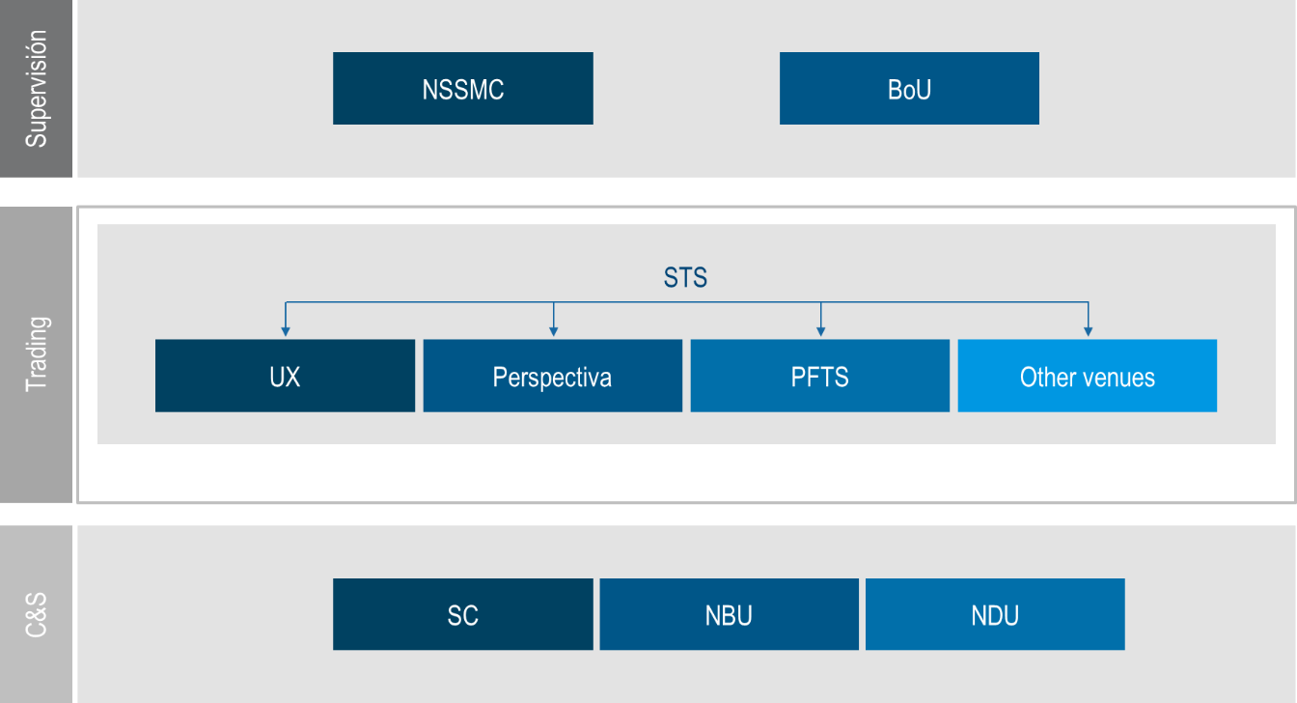

- Consolidation of post-trading. In this phase, the clearing and settlement layers will consolidate into two different entities:
  - Central securities depository (CSD). This entity will take all the current post-trading companies (NBU depositary, NDU and SC) related to:
    - Registry of issues across the different asset types (bonds/shares):
      - Maintenance of the book entry registry system for listed and non-listed securities
      - Management of the accounts (proprietary, client, collateral…)
    - Settlement services:
      - Validation and matching of settlement instructions
      - Management of settlement instructions (maintenance, recycling, cancellation)
      - Cross-checking with CCP
      - Collateral management
      - Connectivity to external systems
    - Corporate actions management:
      - Dividends
      - Coupons
      - Voting rights
      - …
    - Links with other systems (NBU, CCP, foreign CSDs, …)
  - Central counterpart (CCP). This task should be carefully assessed. In principle, clearing services, unlike registry, settlement and depositary services, can be considered a commodity, as far as they do not represent a national interest. Nevertheless, a CCP -depending on the volume of activity- can take a large amount of risk and become systemically important. In other words, the Ukrainian market could rely on the clearing services of an international CCP or have its own CCP. This entity will take all the current post-trading companies (NBU depositary, NDU and SC) related to:
    - Clearing transactions
      - Allocation and reassignment among accounts
      - Give-up/Take-up transactions
      - Position transfers
      - Cancellations
      - …
    - Risk management
    - Collateral management
The market structure of the post-trading layer would look like the following figure:
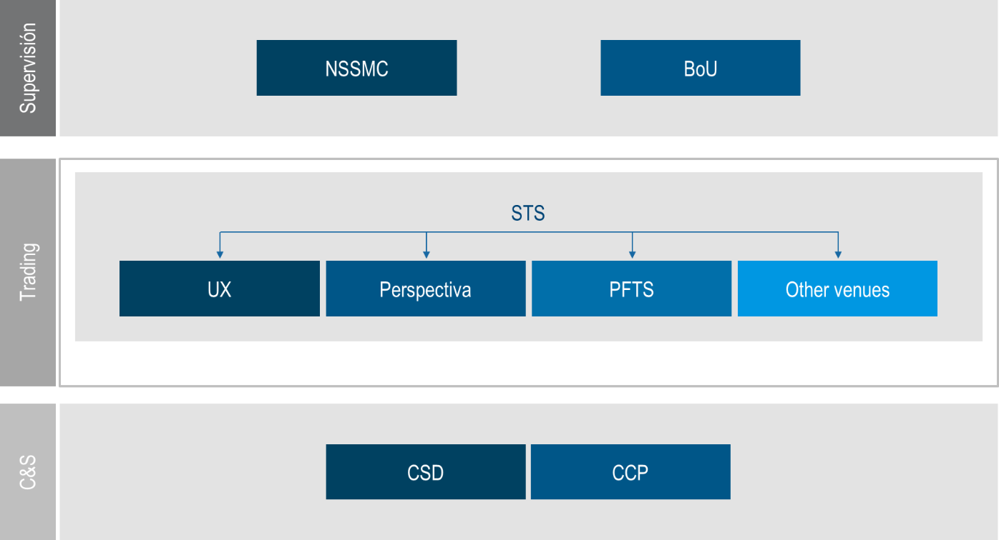

- Corporate consolidation of the trading and post-trading layers. In this phase, the trading, clearing and settlement companies will merge under the umbrella of a holding company (HC), which will own 100% of the shares of each and every company, in exchange of a shareholding of the HC.
As a result, the HC will be the operator of the Ukrainian financial markets and infrastructures, including fixed income, equity and derivatives markets, and the post-trading infrastructures, CSD and CCP.
The HC will have a Board of Directors (executive and non-executive) in charge of:
  - Definition of the general strategy and Management directions of the whole group.
  - Nominations and appointments.
  - Supervision of the top management performance.
  - Corporate organisation and structure, including the Executive Committee.
  - Surveillance of transparency of information to shareholders and markets.
  - Identification and analysis of the Group main risks, including a Risk Policy.
  - Supervision of internal controls.
  - Any other responsibility determined by the Shareholders meeting.
- Eventually, the HC will be publicly listed through a public offering. The format will depend on the market conditions:
  - Issuance of new capital.
  - Offering of existing capital.
As a result, once this phase is concluded, the HC will be easily valuated by the market and it will be subject to the market discipline as a listed company.
Recommendation 1
Consolidation of all market infrastructures.
- Trading layer: the introduction of the STS that would facilitate, both domestic and foreign investment.
- Post-trading layer: simplify the existing infrastructure, improving the administration of the settlement, registry and clearing bodies and therefore be able to provide better services.
- Corporate consolidation: merging all trading companies and their shareholders under the same umbrella in a Holding Company will allow the management of the Ukrainian market as one single company.
- Public listing of the Holding Company: the company resulting from the merge will be easily evaluated for public offering.

  - BUSINESS, FUNCTIONAL AND TECHNICAL REQUIREMENTS FOR THE TRADING LAYER
    - Business requirements
In order to grant an authorisation as a regulated market, NSSMC shall assure that the market operator and the systems of the regulated market comply with the set of requirements stated on the corresponding law. It is not only relevant to have well defined the grounds for authorization, but also to count with the tools to monitor that those requirements are constantly met.
The requirements for authorisation must cover several issues, such as the management body of the stock exchange, organizational requirements, technical requirements that ensure proper functioning, admission to trading, suspension and removal of securities from trading, access or admission to market members and disclosure of market information.
It is recommended that NSSMC solves the authorisation procedure within 6 months and that NSSMC maintains a list of regulated markets for which Ukraine is the Home Member State.
Our recommendation in order to grant an authorisation is that NSSMC obliges the market operator and the systems of the regulated market to comply with the requirements set-out below.
      - Authorisation requirements
The applicant to become a market operator shall comply with the requirements set by the NSSMC, in the Regulation on Stock Exchange functioning. These requirements shall be the following:
- The designation of a market operator that shall be a limited company, whose main functions shall consist in the administration and management of the market, together with the supervision.
- The members of the governing body and the individuals who exercise senior management functions of a market operator shall have a recognized reputation and sufficient knowledge, skills and experience and dedicate sufficient time to perform their duties.
- The shareholders with a significant participation in the governing body of the market operator must be suitable.
- The market operator shall have available and adequate financial resources in order to assure the well-functioning of the market, taking into account the nature and scope of the operations carried out therein and the type and degree of risk to which the market is exposed.
- The market operator shall have adequate rules and negotiation procedures that accomplish the requirements previously stablished by NSSMC.
- The market operator shall have suitable systems, procedures and mechanisms to assure the market functioning and its ongoing supervision.

The authorisation request must include by the following documents:
  - Proposal of Articles of Association for the market operator
  - Proposal of Market Rules
  - Activity program. This document must contain the following aspects:
    - Stock Exchange organizational structure and shareholders ownership structure.
    - Description of the types of services provided.
    - Financial instruments available to trading in the market.
    - Description of the human resources used to provide authorised services.
    - Description of the financial resources, including the detailed information as referred in point 3 above related to the resources provided by significant shareholders.
    - Description of technical resources used to provide authorised services.
    - Description of legal resources used to provide authorised services.
  - Policies and procedures established for compliance
    - Name of the person/s responsible for the approval and maintenance of the compliance policies and procedures.
    - Mechanisms put in place to supervise and ensure compliance policies and procedures.
    - Notification of infractions and measures taken in case of any violation that could lead to non-compliance of the initial authorisation conditions.
  - List of outsourced resources
    - Detailed description of outsourced functions.
    - Description of the controls put in place to ensure the outsource functions are correctly performed.
Recommendation 2
The authorization process shall ensure that the applicant complies with the following requirements:
  - The applicant shall be a limited company established with the purpose of administration, management and supervision of the securities market.
  - The applicant shall have, in its board and management bodies, persons with recognized reputation and sufficient knowledge, experience and skills for the functions each of them are assigned to.
  - The shareholders of the applicant must be suitable according to the NSSMC.
  - The applicant shall prove sufficient available and adequate financial resources to assure it social object.
  - The applicant shall have adequate rules and negotiation procedures as well as suitable systems, technical procedures and mechanism to ensure market functioning and supervision.
The authorization procedure shall include complete relevant information to assess all legal, operational and technical aspects of the applicant, including at least the following:
- An activity program that includes relevant legal, organizational, operational and technical aspects of the stock exchange.
- Description of policies and procedures put in place to ensure that the requirements for authorisation are constantly met.
- List of resources/functions that are outsourced and description of the controls put in place to ensure these functions are correctly performed.
Suspension of market operation licensing procedure
NSSMC can withdraw the authorization on those cases where:
  - the authorization was granted by making false statements or upon an irregular, false, or dishonest information.
  - the regulated market does not make use of the authorisation within 12 months, expressly renounces the authorisation or has not operated for the preceding six months.
  - the regulated market ceased to meet the conditions under which the authorization was granted and fail to provide effective remedies to this breach within the timeframe demanded by the NSSMC.
  - the regulated market systematically commits serious breaches of the financial markets laws and other relevant regulation.
  - the regulated market does not perform the activities for which the authorization was granted.
The withdrawal or suspension procedures must follow the general disciplinary or penalty procedures of NSSMC. In any case, the suspension will be in force for a period to be determined by the NSSMC and will be properly announced.

Recommendation 3
The NSSMC will be entitled to remove, withdraw or suspend an authorization to operate a market when:
- The authorization was granted upon an irregular, false, deceitful or dishonest requirement.
- The conditions under which the authorization was granted are no longer met.
- Serious breaches of the financial markets laws and other relevant regulation are systematically committed.
- No activity is carried out under the granted license.
      - Capital requirements
The capital of the market operator shall be the necessary to assure the achievement of the social purpose of the market operator at any time.
A quarterly statement of the exchange operator capital requirements shall be presented to the NSSMC. The own resources shall be those that allow guaranteeing that the market operator can face the operational, legal, business, custody and investment risks. Likewise, own resources shall be sufficient to ensure an orderly liquidation of the market operator’s, or a restructuring of activities, being those carried out within an appropriate period of time.
In this regard, only those resources that are invested in cash or highly liquid financial instruments with minimum credit and market risk will be considered as computable own resources.
For this purpose, the own resources that cover the different risks of the entity, such as operating, legal and custody, investment, business and liquidation or restructuring shall be differentiated. Likewise, information about the assets in which said own resources are invested shall be provided.
Some estimates that could be used as reference when calculating the resources to be allocated are the following:
- Business risk: 25% of the operation costs;
- Operational risks: 15% of the average of the last 3 year income should be allocated as resources;
- Credit risk: to be evaluate depending on the functions assumed by the market operator;
- Liquidation risk: the resources allocated should be at least the operating costs of 6 months.
The own resources shall be composed of:
  - The subscribed capital, plus the corresponding issue premium, to the extent that it has been disbursed and fully serves to absorb losses in normal situations and, in the case of bankruptcy or liquidation, have lower priority than all other credits.
  - Undistributed profits.
  - Reserves.
In the quarterly statement of own resources, the exchange operator shall provide information on the own resources maintained to facilitate its orderly functioning, taking into account the nature and scope of the operations and the type and degree of risk to which it is exposed, according to the granted authorization. Likewise, it shall be accompanied by an explanatory document that includes the methods for calculating capital requirements, according to the risk approach taken, the estimates used and the different adverse scenarios considered.
The very first quarterly statement, shall include an explanatory report detailing the methodology and the criteria used to determine the own resources allocated to facilitate its orderly operation, taking into account the nature and scope of the operations that are carried out and the type and degree of risk to which they are exposed.
Moreover, when there are significant changes in the assumptions on which the estimates are based and there is a need to update the calculation methods, the market operator shall submit to the NSSMC an explanatory report that explains the circumstances that have motivated those changes, the changes made and the effects on capital requirements.
The regulation should fix the minimum capital requirements with which market operators should comply in order to be authorized, and in doing so, the regulation should take into account the specific nature of the risks associated with such markets.
In this regard, market operator should hold a minimum account of capital and, in any case, have available sufficient financial resources to facilitate its orderly functioning considering the nature and extent of the transactions made on the market and the range and degree of the risk to which the market is exposed, taking into account our recommendations on the percentages to be allocated as resources.
The draft law establishes an initial capital of no less than 25 million hryvnias that can consist of one or several of the following: i) capital instruments complying with the requirements of the National Securities and Stock Market Commission, ii) issuance income regarded as capital instrument, iii)accumulated profits or losses, iv) accumulated other aggregate income, and v) other reserves.

Recommendation 4
The market operator in considering its owns resources has to take into account the risks associated to its social object:
- Business risks
- Operational risks
- Credit risks
- Liquidation risks
- Other intangible but measurable risks

The NSSMC shall ensure that the capital requirements are sufficient to achieve the social purpose of the market operator. To this purpose:
- The market operator shall present to the NSSMC quarterly statements that prove that resources are invested in highly liquid financial instruments.
- The quarterly statement shall be accompanied by an explanatory document with the methods used for calculating capital requirements according to the risk approach taken.
      - Organisational requirements
A regulated market shall have adequate organisational requirements. Particularly, the regulated market shall define and make available the measures to clearly detect and address potential adverse consequences for the proper functioning of the market or its market members that might derive from a possible conflict of interest between the market and, its members, its shareholders or its managers.
Adequate risk management
The regulated market has to have the arrangements for a proper risk management. It should have systems to identify all significant risks to its operation and put in place effective measures to mitigate those risks.
The criteria to manage the inherent risks of the activity carried out by the market operator can pursue the interest of the market operator and the maximisation of its value, profitability and efficiency.
The market operator shall implement a risk control and management policy, which must include a Corporate Risk Map that includes business risks and corporate risk.
  - Operational risk: that is the risk of direct or indirect losses arising from inadequate or failed internal processes, people and systems, or from external events. This operational risk can be the following:
    - Risk of fraud: this is the risk of action taken to avoid a regulation, which may cause damage to a third party.
    - IT risk: this is the risk of faults in the IT and electronic systems used by the market operator that affect either internally or the market. They may arise as a result of communications errors, hardware or software malfunctions.
      - Risk of inadequate design of market data model, system network configuration, software, etc.
      - Risk of failure in the software version change, due to lack of sufficient testing.
      - Risk of IT security breach.
    - Risk of administrative errors: this is the risk that arises from erroneous calculations, improper execution, faulty manual operations, or because databases have not been updated.
  - Market risk: These are the current or potential risks posed by adverse movements in interest rates or changes in prices or share prices, or variations in trading volumes.
  - Liquidity and solvency risk: Defined as the risk where the market operator is unable to meet its payment commitments.
  - Credit or counterparty risk: The risk arising in the event a debtor defaults on its payment commitments, or its credit rating is impaired. This includes, amongst other scenarios, risk of non-payment of bills or charges.
  - Industry risks: this is a compliance risks in connection with regulatory changes, the Company’s reputation, sector competences, relations with stakeholders and the political, economic, legal and tax environment.
  - Business risks: these are the risks arising from the specific activities of the market operator:
    - Risks of inadequate functioning of the market: Possibility of errors arising in listing, trading or supervision processes to prevent adequate overall functioning of the trading system.
      - Risk of having incomplete or inaccurate information prior to the listing process.
      - Risk of having wrong functioning in the price formation process or in the trading system.
      - Risk in the management of listed instrument or market members that blocks the correct trading.
      - Risk of wrongful allocation of technical infrastructure capacities.
  - Other non-financial risks: environmental risk - possibility of damage being caused to the environment due to the market operator’s activity - and the risk of corruption and bribery - possibility of non-compliance with ethical standards and regulations normally leading to administrative infringements and even crimes. These risks have to be assessed in the case they have an impact in the market operator.

Recommendation 5
The market operator shall implement a risk control and management policy with a corporate risk map covering:
- Business risk
- Operational risk (risk of fraud, IT risk, software failure, IT security breach, etc.)
- Market risk
- Liquidity and solvency risk
- Industry risk
- Other non-financial risk

Sound management of technical operations of the system
From the technical point of view, the regulated market shall have sound management of technical operations of the system, and put in place effective contingency arrangements. The systems, procedures and mechanisms shall guaranty that the trading systems:
  - are resilient.
  - have enough capacity to manage the volume of orders and messages during the maximum expected activity of the market.
  - ensure orderly negotiation under conditions of strong market tension.
  - have been fully tested to comply with the formerly.
  - are subject to effective mechanisms of continuity of activity to ensure the maintenance of their services in case of dysfunction¹⁰.
  - reject orders that exceed predetermined volume and price thresholds or that are manifestly inaccurate.

Recommendation 6
The NSSMC shall ensure that the market operator has sound management and technical systems.
Suitable market rules
The market rules shall be transparent and non-discretionary and the procedures shall provide for fair and orderly trading, as well as efficient finalization of the transactions executed under it.
In this regard, the market operator shall prepare a draft of market regulation that will contain at least the applicable rules on the following issues: negotiation of financial instruments, issuers, members, guarantees regime, type of transactions, negotiation procedures, rules on clearing, settlement and registration of transactions, distribution of dividends and other corporate events, market supervision and other organisational measures related, among other matters, to conflicts of interest and risk management.
Any substantial modification in the market regulation, shall be previously approved by the NSSMC and issuers which instruments already admitted to trading on the market should have the right to be consulted. In section 2.5 we propose some recommendations on market rules that from our point of view would help the Ukrainian market to concentrate liquidity and improve the price discovery mechanism.
Sufficient financial resources
Regarding the economic regime, the market operator shall have sufficient own resources to cover the orderly functioning and operational, legal and investment risks.
To ensure the market operator complies with sufficient financial resources, the NSSMC, shall request the market operator information regarding the financials of significant shareholders. This requirement should be applicable to main shareholders of the market operator at the initial authorization procedure. In the case that the NSSMC has doubts or does not know current authorized exchanges’ shareholder, this obligation should also be applicable to renew authorisation. Likewise, this obligation should also be applicable to any change in participation that is above certain threshold to be determined by the NSSMC.
This information shall be related to:
- Details on the use of private financial resources and the origin and availability of the funds, including any relevant documentary support to provide evidence to the NSSMC that no money laundering is attempted through;
- Details on the means of payment of the significant participation /or change in acquisition and the network used to transfer funds;
- Details on access to capital sources and financial markets including details of financial instruments to be issued, if that is the case;
- Information on the use of borrowed funds including the name of relevant lenders and details of the facilities granted, including maturities, terms, pledges and guarantees, as well as information on the source of revenue to be used to repay such borrowings and the origin of the borrowed funds where the lender is not a supervised financial institution;
- Information on any financial arrangement with other shareholders;
- Information on assets of the relevant shareholder or proposed acquirer which could to be sold in order to help finance the relevant shareholding, as well as the conditions of the sale, including price, appraisal, details regarding the characteristics of the assets and information on when and how the assets have been acquired.
- Express indication of the intentions of the significant potential shareholder in relation to the market operator, including whether or not it intends to exercise any form of control over the it, and the rationale for that action;
Financial resources shall also cover, when necessary, liquidity and restructuring risks. The resources must be available, at the time of authorisation and on an ongoing basis.
The market operator shall submit annually to the NSSMC estimated budget with the detail of the prices and fees that apply to the provided services. We recommend to establish the obligation of submission before the 15th November, so as to have enough time to request additional information if needed.
The market operator shall submit, in addition to quarterly statements, the annual accounts to the approval of the general meeting of shareholders previous audit and shall also submit to the NSSMC the annual internal audit.

Recommendation 7
The NSSMC will be entitled to request the market operator:
- Information regarding the financial of relevant shareholders, initially and at any major change in ownership which threshold is above the one established by the NSSMC.
- Quarterly financial statements to oversight that the market operator has sufficient own resources to cover the orderly functioning and operational, legal and investment risks.
- An annually estimated budget with the details of the fees and tariffs to be applied.

      - Management body requirements
A regulated market must be managed by a market operator. The latter must perform the functions related with the normal organisation and functioning of the market and NSSMC shall verify periodically that it fulfils its obligations.
The management body of the market operator shall have sufficiently good repute, possess sufficient knowledge, skills and experience and commit sufficient time to perform their duties as market operator. In order to assure this, the market operator shall allocate adequate human and financial resources to the induction and training of the management body.
Members of the management body shall fulfil the following requirements:
- Commit sufficient time to perform their functions in the market operator.
The time commitment should be adapted to the functions and responsibilities and shall always be recorded in writing.
- Possess adequate collective knowledge, skills and experience to be able to understand the market operator’s activities, including the main risks.
The market operator shall put in place a recruitment and diversity policy when recruiting. Theoretical knowledge as well as the practical experience gained in previous occupations must be considered. Regarding education, the level and profile, together whether it relates to financial services or similar shall be taken into account. Concerning the professional experience, it shall be valued if the knowledge has been gained from a managerial position over a sufficiently long period.
- Act with honesty, integrity and independence of mind to assure an adequate decision making.
To value this issue it shall be taken into consideration whether the prospective member has been:
  - subject to an adverse decision in any proceedings of a disciplinary nature brought by a regulatory authority or if he is the subject of any such proceeding that is not concluded,
  - subject to an adverse judicial finding in civil proceedings before a court in connection with the provision of financial or data services, or for impropriety or fraud in the management of a business,
  - part of the management body of an undertaking which was subject to an adverse decision or penalty by a regulatory authority or whose registration or authorisation was withdrawn by a regulatory authority,
  - refused the right to carry on activities which require registration or authorisation by a regulatory authority,
  - part of the management body of an undertaking which has gone into insolvency or liquidation while the person was employed by the undertaking or within a year of the person ceasing to be employed by the undertaking,
  - fined, suspended, disqualified, or been subject to any other sanction in relation to fraud, embezzlement or in connection with the provision of financial or data services, by a professional body,
  - disqualified from acting as a director, disqualified from acting in any managerial capacity, dismissed from employment or other appointment in an undertaking as a consequence of misconduct or malpractice.
Regarding the number of members that can be part of the management body, this shall be in line with the individual circumstances and the nature, scale and complexity of the market operator’s activities. It must be noted that except in special circumstances, members of the board shall not hold at the same time positions exceeding more than one of the following combinations:
  - one executive directorship with two non-executive directorships,
  - four non-executive directorships.
It shall be noted that, directorships held in organisations which do not pursue predominantly commercial objectives should not be counted when calculating the number of directorships.
The market operator shall create a nomination committee that will carry out the following tasks:
- Identify and recommend candidates to fill management body vacancies for the approval of the management body.
- Assess the structure, size, composition and performance of the management body, and make recommendations to the management body with regard to any changes. This shall be done at least annually.
- Assess the knowledge, skills and experience of the members of the management body and report to the management body accordingly. This shall be done at least annually.
When assessing the suitability of the management body, the following areas shall be considered: financial accounting and reporting, strategic planning, risk management, compliance and internal audit, information technology and security, local, regional and global markets where applicable and the regulatory environment.
- Periodically review the policy of the management body for selection and appointment of senior management and suggest recommendations.

Recommendation 8
The NSSMC shall verify that the management body of the market operator is suitable. Thus, it shall meet the following requirements:
- Commit sufficient time to perform their functions.
- Possess adequate collective knowledge, skills and experience.
- Act with honesty, integrity and independence of mind in their decision making process.
The market operator shall create a nomination committee that is able to continuously assess the structure and the performance of the management board, as well as to identify and recommend suitable candidates in the event of changes.
      - Corporate governance for stock exchanges
The management body must define and oversee the implementation of the governance arrangements that ensure effective and prudent management of an organisation, including the segregation of duties in the organisation and the prevention of conflicts of interest.
We recommend NSSMC to establish corporate governance guidelines so as to align with European requirements for regulated markets as far as possible. In this regard, the regulation concerning corporate governance issues affecting regulated markets must be more detailed. A coherent approach to corporate governance would align the requirements for all market operators:
  - The management body of the market operator shall determine the corporate governance policies that are applicable to regulated markets and MTF. As a result the management body must study the recommendations on corporate governance and apply best practices. The definition and implementation of the stock exchange corporate governance policy must be presented to the NSSMC.
Based on international best practices, the corporate governance policies must include:
  - Policies regarding the management board:
  - Management board meetings
  - Management board composition
  - Selection and appointment of board members
  - Re-election of board members policy
  - Resignation of board members
  - Knowledge of board members
  - Evaluation of board members
  - Description and functions of board members duties (president, secretary, etc.)
  - Policies regarding the management body: Description of the tasks, functions and responsibilities of the managing director and other directors in charge of the management of the company:
  - Means of communication between the management board and de company directors.
  - Evaluation of managing directors: The management body of an exchange shall have sufficiently good repute, possess sufficient knowledge, skills and experience and commit sufficient time to perform their duties as market operator. The members of the management body shall commit sufficient time to perform their functions in the market operator.
  - Designation and resignation of managing directors.
  - Policies regarding information provided to the board members and how the information is disclosed:
  - The procedures in place to provide information and assistance board members in the course of their duties to make their corresponding decisions. The management body shall possess adequate collective knowledge, skills and experience to be able to understand the market operator’s activities, including the main risks.
  - The information that any of the board members needs to provide to the company to ensure there is no conflict of interest, including any judicial process they might be into.
  - Information to disclose to the general public and the NSSMC.
The management body shall monitor and periodically assess the adequacy and the implementation of the exchange strategic objectives, the effectiveness of their governance arrangements and the adequacy of the policies relating to the provision of the exchange market and take appropriate steps to address any deficiencies.
The NSSMC needs to be informed and have the capability to approve or refuse any change in the management body of the regulated market and any change in the ownership structure or in the implemented arrangements that may affect the duties as market operator.

Recommendation 9
As part of the organizational requirement, the NSSMC should request market operator of stock exchanges and MTF to provide a comprehensive set of corporate governance polices that includes:
- Policies regarding the management board.
- Policies regarding the management body.
- Policies regarding information generated in the market operator and its disclosure.
All these policies need to be assessed and reviewed annually and informed the results (report) to the NSSMC.
      - Internal rules and conflicts of interest
The market operator of a regulated market and/or MTF shall take the necessary steps to identify and to prevent any conflict of interest that may derive from the compliance of its duties.
These conflicts of interest may arise in the following circumstances: between the market and its managers, their employees or any person that is linked to them. In sum, it can be any situation in which the personal interest of the interested parties or of the persons related to their activities outside the regulated market, family relationships, personal assets, or for any other reason may enter, in collision, directly or indirectly, with the interest of the stock exchange.
Therefore, it is expected that interested parties act with due impartiality, without putting in any event its own interests above to those of the stock exchange, as well as those of its shareholders.
To manage conflicts of interest, the stock exchange should have a controlling body that produces an effective written Conflicts of Interest policy and ensures that it is implemented and maintained in time.
In this regard, the NSSMC should request, within the initial authorisation procedure, the following information:
  - Conflicts of interest management policy
  - Procedure to prevent and manage possible conflicts of interest.
  - Inventory of conflicts of interest, actual and potential conflicts of interest
Conflicts of interest management policy and procedure
The market operator of a regulated market and/or MTF shall elaborate an Internal Code of Conduct (ICC) that shall be approved by the board of directors. The ICC shall define the principles and the framework of action that must be observed by employees and managers of the market operator in the field of securities markets.
The ICC shall specify, firstly, the interested parties and persons that are subject to the ICC and the instruments (securities) affected. It should also establish the internal bodies within the market operator that are responsible for the interpretation of the code, as well as for the approval of any rules or further instructions.
The ICC shall contain main conduct principles, among others:
  - To develop an orderly, diligent, prudent and transparent management, ensuring the integrity of the markets.
  - To know and act with full respect to the rules, dispositions and decisions approved by the authorities and competent bodies.
  - To provide the necessary collaboration to the supervisory body (NSSMC).
The persons subject to the ICC shall not use for their own benefit the information they have obtained from the market operator, subsidiaries or its suppliers, customers or shareholders. More specifically, they should refrain from the use of that information that it is obtained, used or applied as a consequence of the functions assigned to them, whether it refers to the market operator, other entities or people.
Secondly, the ICC shall define as well the principles of actions for conflicts of interest and the procedures to prevent and manage them.
Thirdly, the ICC shall set the obligations of reporting of transactions made regarding securities subject to the Code as well as the limits the market operator imposes to persons subject to the ICC on transactions on affected securities.
Fourthly, the ICC has to include a reference to inside information, the main principles of action with privilege information, disclosure of this information and market manipulation.
Lastly, the ICC shall reflect a reference to measures to be taken in case of infringement, in addition to what is established by the NSSMC or the law.
Inventory of Conflicts of interest
The market operator has to identify situations that may constitute a conflict of interest and which can be similar to the following:
  - Direct or indirect relationship of a member of the board of directors or senior manager of the market operator with one of its clients.
  - The participation of a member of the board of directors of the market operator in activities other than those performed as a member of the board of directors.
  - The direct or indirect relationship of a manager or employee of the market operator with related persons, or with any client.
  - A director of the market operator, employee or related person who carries out activities other than those developed for their role as manager or employee of the market operator.
  - Participation of a member of any of the internal organizational structures of the market operator in activities other than those developed for their function as a member of any of mentioned bodies.
  - Participation of a member of any of the internal organizational structures of the market operator or its related persons in companies providing services.

Recommendation 10
The market operator of stock exchange and MTF shall produce an Internal Code of Conduct that defines main principles and framework of action to be observed by all employees and related persons:
- The main conduct principles should be devised to ensure prudent and transparent management and market integrity.
- The ICC should contain principle of actions for conflicts of interest and procedures to manage them
- The ICC shall include a title on reporting obligations and a title to prevent market abuse.
The market operator has to identify situations that may constitute a conflict of interest.

    - Technical requirements
From the technical point of view, exchanges shall count with a sound management of technical operations of the system. The market operator must assure to implement all necessary measures so as to ensure the security and confidentiality of the information and the continuity of trading in case of disaster.
      - IT Software recommendations
The solution shall be scalable and flexible, allowing to an easy integration with other applications.
Latency
The market operator shall have systems that allow low latencies, but focusing in this issue shall not be a top priority for the Ukrainian market, as on one side, most traded instruments are fixed income, and on the other, latency is an issue that acquires special relevance when exchanges provide co-location services. Since the equipment’s of some market members can be located within the same data centre as the matching engine and market data systems, round trip latency reduces significantly and from then onwards, exchange latency becomes critical. This kind of services provide market members with low microsecond access to the trading platform and real-time market data services, helping to manage risk and improving certainty of execution.
Time stamping
Trading venues shall synchronize the business clocks used to record the date and time of any reportable event. Timestamping aim is to improve transparency, by recording the timing in which any relevant action takes place, allowing the tracking of best execution obligations, as time stamps records the time the exchange gateway receives the order and the timing of any further action over that order.
In order to assure this, trading venues and their participants shall establish a system of traceability to UCT. This said, for the time being, we recommend the synchronization of the business clocks, leaving for a later stage the establishment of a traceability system to UCT.
Traceability
As mentioned previously, the system must provide traceability of orders, as this will allow the market operator and NSSMC monitoring activities. The traceability and record of any action will allow for example to control market members conducts. For instance, it will allow to supervise the market members that enter orders into the auction or during regular trading, deleting them or amending them before execution, giving a potentially misleading impression of the level of liquidity in the market.
Connectivity
Trading venues shall follow industry standard protocols and interfaces. The trading system shall count with a standard protocol interface, such as FIX, in order to allow an easy integration, either with third-party or proprietary solutions across the whole trade lifecycle. This issue is critical to promote market development, reducing risk by allowing automatization of procedures, reducing the timing of operating in the market and increasing security and reliability.
Detection of Manual Data entry Errors
The software should be able to detect any manual data entry that can put at risk the correct functioning of the market. This is commonly known as fat finger. The system shall be able to detect any errors made by hitting the wrong key or mouse missclick. In this regard it should not only be able to select certain filters to detect this errors but also create alerts to warn the user.

Recommendation 11
- Ukrainian market operators, their members and participants shall record accurate timestamps for any and all reportable events.
- The market operator shall put in place systems that allow easy integration by standard protocols, such as FIX.
- The software shall ensure that it has the adequate measures to avoid any malfunction due to human data entry or erroneous data entry.
      - Infrastructure recommendations
The market operator must count with two mirror sites located at a sufficient distance as to assure that an inclemency does not affect the two physical locations. There are different hypotheses regarding what to consider a safe and adequate distance, as it variable depending to the geographic location, weather conditions, etc. To this end, it is recommended to perform a risk assessment in order to define such safe distance. The assessment must evaluate several factors, such as the proximity to dangerous industrial areas or relevant emblematic buildings, the seismic risk, the probability of other natural disasters, etc.
For the creation of the data center, it is recommended to take into account the international standards on this matter, established by the Uptime Institute. Uptime Institute classifies the data centers in terms of the requirements of a company concerning the availability of systems. For this reason, Uptime Institute has created the "Tier Classification System", which classifies data centers in 4 different levels, being level I the most basic.
At a minimum, the market operator shall count with a Tier II data center: “Tier II facilities include redundant critical power and cooling components to provide select maintenance opportunities and an increased margin of safety against IT process disruptions that would result from site infrastructure equipment failures. The redundant components include power and cooling equipment such as UPS modules, chillers or pumps, and engine generators”. That said, it would be advisable to for the market operator to count with a data center with a higher level.
In any case, when creating the data center, the market operator must take into account all applicable local or regional regulations.
        - Physical measures
The present section includes some physical measures the market operator must put in place to ensure the well-functioning of the infrastructure.
Electricity
The data centers shall count with a generator group and it is strongly advised, that they are electrically connected to two different power supply companies.
Like any critical installation, the entity must have uninterruptible redundant power supplies (UPS) to stabilizing the input voltage, remove harmonics and to detect a possible power cut in order to instantaneously support the load with its own batteries. When a power cut takes place, an order will be sent to the group of generators so as to turn on.
Ventilation and cooling systems
The data center must have an adequate cooling equipment for maintaining a constant temperature. For greater safety, it is recommended that the system is provided with a double compressor.
In any case, the system must always count with additional machines, in order to replace them in case of failure.
Fire extinguishing systems
The data center must have a fire extinguishing system that allows the detection and extinction of a fire in the shortest possible time so as to minimize potential damages.
Among the different options available, the use of nebulized water is recommended, since it eliminates the possibility of people becoming intoxicated (as it can occur with gas) while avoiding damage of electronic equipment.
Security measures
Data and IT infrastructure security are two main issues a market operator must be concerned about. Therefore, the data center must have in place various security measures to assure keeping the hosted data safe and confidential. Therefore, it is recommended to monitor the facilities in three different aspects:
  - Security monitoring
  - Maintenance monitoring
  - Technical monitoring
The first two must be carried out 24 hours a day, 7 days a week; while technical monitoring may be limited to a slightly broader schedule than that of market sessions.
Regarding security monitoring, the access to the data center must be restricted to authorized personnel. A double security check control is strongly recommended (such as the use of a card and fingerprint sensor, for example). Additionally, visitors must sign in and sign out and remain under supervision at all times. To strengthen security, the data center must count with 24 hours a day surveillance, installing security cameras, both within the data center and at the entrances.
The entity must also keep record of all authorized access and account who and when accesses the data center. This information must be available for possible audits.
        - Logical measures and other relevant issues
Securing the data
The market operator shall adopt specific measures to secure the data, such as data encryption when transferring files, data backup and recovery, traffic monitoring, etc.
Monitoring
The systems shall be monitored at all times. Different issues shall be overseen, such as uptime, energy, bandwidth in use, storage, etc.
Scalability
The market operator shall set up a data center with sufficient capacity in case of a future need of additional physical space, storage, power etc., due to the increase of the activity of the exchange, either due to an rise in transactions or an expansion in the services provided by the market operator (such as co-location services).
Organisation
The devices shall be integrated in the data center via standardised and supportable procedures. Additionally, the server racks shall be laid out in a logical manner.

Recommendation 12
- The market operators shall have a Data Centers separated by a safety distance.
- The DC shall count with the following physical measures:
  - Generator group electrically connected to two different power supply companies
  - Fire extinguishing systems
  - Multi factor authentication and cameras to monitor the entrance at all times
- The DC shall count with the following logical measures:
  - Data encryption, data backup and recovery and traffic monitoring
  - Monitoring system
  - Easy scalability
      - Communication recommendations for exchanges
Connection between the sites
Both sites shall be connected with two point to point lines from different providers.
Regarding bandwidth, this will depend on the data flow that the line must support. In any case, the minimum bandwidth must allow 50% of the line to be not busy.
Connection of the members to the data center
Market members must have a connection to both sites. It is also desirable that connections are made with different operators.
The following diagram reflects the recommended infrastructure:
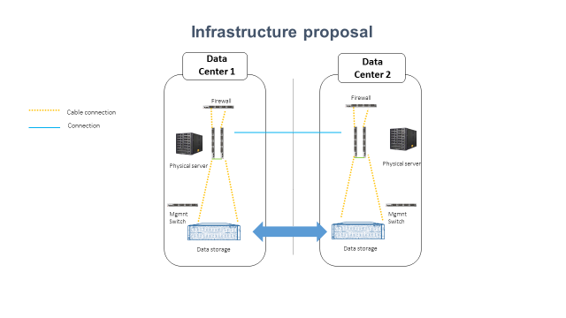

  - Firewall with access control lists
  - Management Switch: Allows the connection of the infrastructure with other systems
  - Physic server: CPU, RAM, virtual machines, etc.
  - Replication can take place at cabin level or at server level

Recommendation 13
- The DC shall be connected by two point to point lines. It is advisable that the lines are of two different providers.
- Market members must have connection to both data centers.
      - Capacity and resilience recommendations
The market operator should put in place measures and conditions to guarantee the continuity of their services.
Systems must have sufficient capacity and resilience to provide an orderly trading conditions even under stress.
The market operator must test the suitability of their members to carry out their activities without putting the whole system at risk. Market members should be subject to conformance tests to check their ability to operate. This testing should include:
  - Order management functions (entry, modification, cancellation) over a wide range of financial instruments.
  - Connectivity functions.
  - Knowledge and experience.
The market operators must guarantee their systems capacity to operate under stress conditions. In this line, trading systems must be subject to proper testing, particularly the processing of high number of messages. To this end, they must set systems parameters to be monitored on a continuous basis: number of messages per second, number of messages rejected, system performance ratios, etc. There should be established a policy to prevent disorderly trading conditions, such as:
  - Mechanisms to control volatility, such as trading halts.
  - Mechanisms to control market price movements.
  - Trade controls, such as maximum prices and volumes for orders.
Trading venues (exchanges, MTFs…) must have a business continuity plan to be submitted to the NSSMC. This plan shall devise business continuity arrangements to guarantee a proper management of critical situations such as technical glitches, power outages, and unavailability of physical space, deterioration of information or any other severe incident that can shut down the trading activity. The business continuity arrangements should minimize the time needed to resume trading and the amount of data lost.
A business continuity plan should:
  - Define the possible disruptive incidents to be addressed.
  - Detail the procedures to be triggered in each of the cases.
  - Set recovery parameters, such as time to recovery, maximum admissible data loss…
  - Back-up arrangements and procedures.
  - Human resources assigned to the recovery tasks.
  - Periodic review.
Recommendation 14
­ Define the conditions of capacity and resilience of markets
­ Request a business continuity plan from markets
­ Market operators must set the conditions to prevent and avoid disorderly trading conditions:
- Volatility management
- Trade controls
- ….
  - LISTING OF FINANCIAL INSTRUMENTS
    - Admission of financial instruments to trading
The Regulation on Stock Exchanges Functioning provides the grounds for the authorized market to define its rules of operation in respect of admitting assets to trading, suspending and revoking this admission.
For a company to become listed, certain requirements have to be met. The Regulation provides detailed requirements for issuers, distinguishing requirements in terms of type of security (share or corporate bond).
The requirements that must be met for shares before being listed shall be the following:
  - A suitable spread of shares, i.e. at least 25% of the company´s shares must be distributed among investors.
  - A prospectus must be submitted to and registered with the NSSMC for all issues of marketable securities sold through public offerings where the home country is Ukraine.
  - A commitment to publishing relevant information and periodic financial information as required by the Law.
To foster listing of securities, the NSSMC could offer -whether itself or though the stock exchanges or market operator- a service of free professional advice on the listing procedure and the benefits of raising capital through the stock exchanges. This initiative can range from providing information, to training for accessing the market for the first time. The initiative could also include more specific services and products that enable issuers to successfully deploy their entire potential when becoming listed.
The Regulation on Stock Exchanges Functioning provides the grounds for the authorized market to define its rules of operation in respect of assets admission to trading, suspension and revocation.

Recommendation 15
- The NSSMC should update the listing requirements to include as part of the listing procedure the obligation to provide the prospectus and the commitment to publish issuers’ relevant information and financial information.
- The NSSMC could encourage the role of an advisor or counsellor to provide free professional advice, information and training to potential issuers so they can get all the benefits from becoming a listed company.
    - Issuance of foreign companies in Ukrainian Exchanges
In order to promote the market, it would be advisable to develop activities to attract foreign issuers. The Law of Ukraine on amending certain laws of Ukraine regarding the simplification of attracting investments and implementing new financial instruments (9035) applies to any assets admitted to trading on the multilateral trading system, including securities issued by foreign issuers. Therefore, currently, foreign issuances are admitted to trading in Ukraine in the exchanges as long as they comply with the requirements stablished in Section VI of the law. It must be pointed out that this section of regulation is mainly in line with European Legislation prospectus regime.
In regard to exchanges rules, in general, they are in line with this principle. For instance, UX, establishes in Article 12 that foreign issuances are allowed as they count with a document confirming that the securities are admitted to circulation in Ukraine.
Ideally, NSSMC shall count with an easy procedure to allow the listing of foreign securities listed in other countries, following a similar procedure that the one stablished in European regulation. European regulation allows that, once a prospectus has been approved by a competent authority of a country of the European Economic Area (EEA), this document can be used for listings in any other EEA country, without further review of the new country authority. This reduces the additional costs and the delays that a new admission procedure would cause.
The proposed procedure is the following:
  - The issuer shall request the Home Authority to notify the Host Authority in the EEA country.
  - The Home Authority shall provide the Host Authority with a statement that the prospectus has been drawn up in accordance with the Prospectus Directive (Certificate of Approval).
To achieve this it is necessary that the NSSMC establishes bilateral agreements with other national authorities (EEA countries) where the foreign company is located.
Additionally, for the development of the Ukrainian market it would be advisable to promote dual listing. For a company, issuing on a secondary foreign country in addition to the Ukrainian market can increase investor’s visibility and benefit from a lower cost of capital. This may have a positive consequence for the Ukrainian market, as the company will start voluntarily committing to the foreign country standards, which will have a positive impact in the investors’ confidence.
Recommendation 16
NSSMC shall allow European issuers to list on Ukrainian exchanges if their prospectus had been previously approved by a European competent authority.
    - Creation of a specific market or segment for international securities
In this section we include the main issues that must be taken into account to create a specific market or segment for foreign companies in Ukrainian Hryvnias (UAH). Such market or segment of these characteristics would enable Ukrainian investors to trade foreign securities of well-known companies in local currency, avoiding the complexity of having to manage different currencies and the corresponding exchange costs.
The creation of this market would enable Ukrainian investors to invest on attractive foreign companies with an easy and efficient access, reducing risks and avoiding having to comply with different regulation, as trading and settlement conditions would be the same as for local companies.
To attract foreign companies, we recommend the regulation of the new market shall be in line with best international practices, as this will ease companies’ decision on listing on an additional market.
Requirements for listing
In addition to the requirements stablished in the previous section, in order to be traded in this market, foreign securities must meet the following requirements:
  - The security must previously be listed on an Exchange with similar rules to the Ukrainian market or to European Regulation.
  - NSSMC shall set a minimum capitalisation of the company issuing securities.
  - The Central Depositary must set the necessary means to ensure that the balances appearing in the registration system are in line with the information of the central depositary or similar body of the home country.
To this end, the depositaries or similar bodies shall sign relevant agreements between them or either agreements with linking entities to ensure the connection between the Ukrainian depositary and the depositary and registration system of the country of origin.
The request to issue a foreign security to be listed in this market/segment can be requested by the issuer or by a market member.
The rules for trading shall be the same as those envisaged for Ukrainian securities on section ¡Error! No se encuentra el origen de la referencia.. The market shall follow the same trading rules. Rules must include the role of market maker.
Settlement
So as to assure settlement, the following rules shall be observed:
  - If the Ukrainian depositary has an account in the central depositary of the home country, the issuer must appoint and communicate the Ukrainian depositary the settlement member that will assume the task of agent when financial operations take place. This entity will be compelled to follow Ukrainian depositary procedures at all times.
The issuer may either nominate a settlement member to generally assume the role of agent in all corporate transactions or nominate a settlement member to assume the task of agent in each financial operation.
  - If there is a linking entity, that entity must guarantee the exercise of the economic and political rights of the holders regarding each transaction.
Information dissemination
The Ukrainian market, in which the foreign securities are listed, must disseminate any relevant information that the issuer has submitted to the local exchange where the company is listed, ensuring that the information is available immediately. In order to guarantee this, the two exchanges may sign a cooperation agreement in order to assure the disclosure of information and coordinate the supervision mechanisms of the market.
Other alternatives to the signature of this agreement may be:
  - Submission of information through a linking entity or an authorised identity.
  - Submission of information by the market member that promotes the issuance.
  - Submission of information by the issuing entity.
The chosen procedure shall be notified to the NSSMC.
Recommendation 17
The market of foreign securities shall count with the adequate mechanisms to assure the settlement of securities and information dissemination.
  - TRADING REQUIREMENTS INCLUDING THE METHODS FOR PRICE FORMATION
The market operator shall develop market transparent and non-discretionary rules. These market rules should guarantee a fair and orderly trading and ensure the correct price formation process.
Due to the nature and development of the current Ukrainian market, this section provides recommendations to increase market concentration, by way of proposing an auction trading model and improving the price formation process through the generation of liquidity by encouraging the use of market makers.
    - Recommendations regarding the market model
European exchanges follow the European market model. This model covers order driven markets and anonymous trading with the possibility of partial order performance. In this sense, our recommendation is mostly based on concentrating the liquidity as much as possible in order to feed price formation.
Therefore, taking into account the nature of the Ukrainian market, we recommend to promote the trading method of auctions or fixing market, usually used for the most illiquid securities, which consists of one/two daily auctions, following the rules described below, at the end of which an equilibrium price is stablished and transactions are executed.
Auctions or fixing market
In an illiquid market such as the Ukrainian one, it is advisable to put in place auction mechanisms, as they are an efficient method for concentrating liquidity and get a proper price formation.
The auctions system provides an efficient method for price formation, as it allows the interaction of the supply and demand of the market members for each of the securities and concentrates the trading in a particular point of time known by all market members. The auction system, also known as fixing, is used to set an equilibrium and / or closing price, reducing the volatility of the security price.
The following rules are used by European Market models to set the auction price, which could be followed by the Ukrainian exchanges:
  - Rule 1. The price shall be that at which the largest volume of shares is executed.
  - Rule 2. If there are two or more prices at which the same number of shares can be executed, the auction price shall be that which leaves the smallest surplus. The surplus is the difference between bid and ask volumes susceptible of being negotiated at the same price.
  - Rule 3. If the former two conditions provide more than one price, the price of the side with the larger volume (larger weight) shall be taken.
  - Rule 4. If the former three conditions provide more than one price, the price which is closest to the last executed price shall be taken. If this price is within the range of potential auction prices (upper and lower limit), the last executed price is taken.
Recommendation 18
To concentrate liquidity by creating a fixing market based on auctions.
Set opening and closing auctions for each trading session following the procedure described including a random end period.
- Auctions provide an efficient and transparent price formation method.
- Concentrate liquidity due to efficient price formation.
- By setting a random end period the market can avoid price manipulation at the end of the auctions.

Continuous market
Recommendation 19
Use a fixing trading segment for the most illiquid securities.
- Fixing trading segment provides a method that concentrates the liquidity of the securities.
- The fixing trading segment will provide again an efficient transparent price formation method through auctions.
- Carry out a study to determine the most suitable securities to be traded in the fixing modality based on liquidity.
Depending on the liquidity of the security, this may be quoted in a continuous segment or in an auction system segment. It is possible to change from one trading modality to another, according to the evolution of the liquidity of the security.
As the market grows and becomes more liquid, the instruments will be able to evolve from the auction segment to the continuous market. The continuous market should start with an opening auction with a random end to allow to create a transparent opening price. The same principle shall apply to the end of the session, by which with a closing auction with a random end, price manipulation can be reduced.
- Volatility auctions
Volatility auctions are used to ensure price continuity in the continuous market where there is a change in price higher that exceeds pre-set limits. Volatility auctions are triggered when the price at which a value is about to be negotiated is in the limit of the static or the dynamic price range. They are used for price discovery of highly volatile securities. Volatility auctions allow a certain level of control over price formation when securities prices are extremely unstable, therefore reducing excessive volatility.
Volatility auctions generally behave like the opening and closing auctions, with a typical five minutes time frame, plus a random end, during which the auction may close at any moment without prior warning and the shares allocation process begins (trades matched at the resulting auction price).
Recommendation 20
Set volatility auctions for the continuous market
- Volatility auctions allow price discovery when the price of securities is unstable and therefore reduces excessive volatility.
- Determine an appropriate static and dynamic range for each instrument.

Types of orders
In addition to the orders that already exist in the Ukrainian market, the following could be implemented, in order to provide more flexibility to traders:
- Market to limit orders: orders without a price which are limited to the best opposite-side price on the order book.
These orders can be introduced during auctions as well. Market to limit orders cannot trigger volatility auctions. Both market and market to limit orders have priority over limit orders.
- Hidden orders: are large in scale orders not visible for the rest of the market (except in auction) although they are partially executed. These orders can be entered in the open market, including the auction periods, but not in the auction system and they can cause volatility auctions.
- Midpoint orders: They are orders that allow operations to be executed at the midprice of the best bid or ask position at any time in the order book. There is the option to flag an execution limit price and indicate the minimum volume of each partial execution (Minimum Executable Size, hereinafter MES) and the minimum volume for the first execution of the order (MAQ), (even in different trades). If the remaining volume of the order is lower than the MES, the order will be cancelled. For this reason, MAQ must always be equal to or greater than MES. Midpoint orders will be traded outside the principal order book, and may not interact with other orders that are in the aforementioned order book.
They can be introduced in the open market, but not in the auction periods or in the auction system. They do not trigger volatility auctions.
- Combined blocks orders: They are large in scale orders with a visible part and another one no-visible. The visible part works as an iceberg order with two volumes on it called "Volume to show" and "Volume to show high". These orders can be entered in the open market, including auction periods. They cannot be entered in the auction system. The visible part can trigger auctions and these orders participate with their total volume. These trades will contribute to volume and price market statistics.
Recommendation 21
Analyse and determine whether the introduction of new types of orders would allow a greater flexibility for market members, thus increasing trading activity and concentrate liquidity.

Tick sizes
For the configuration of every asset, it is important to set a unit of minimum variation required in the price of each one of the assets traded in the market and differentiating between quotation in continuous market and quotation in an auction system. Tick size regimes need to be adjusted conveniently in order to represent the liquidity of the financial instruments and the average bid-ask spread, bearing in mind the purpose and benefit of enabling reasonably stable prices, without constraining further narrowing of spreads.
Tick sizes were introduced to increase liquidity in the market. If tick sizes are too large or too small, it would be very difficult to match orders and execute trades. With small tick sizes, the counterparty orders would only vary infinitesimally, as market members would try to reduce the bid-ask spread as cost-efficiently as they possibly can in order to save money. Similarly, if tick sizes are too big, it would be difficult to change counterparty orders because even the smallest of variations would involve a large amount of money that market members and its clients are not willing to lose.
Tick sizes should be determined based on the liquidity of the instruments, expressed in terms of the average number of transactions per day, and the price of the submitted orders. According to ESMA, appropriate tick size regimes can be determined taking into account these two variables, although it would be beneficial to study other possible variables such as bid-ask spread or the frequency of trade execution. Nonetheless, considering the average number of transactions and price order as variables it is sufficient to assign a suitable tick size to each financial instrument.
Determining tick sizes individually would be too complex to implement and maintain. However, by enabling a liquidity band with tick size regimes where financial instruments with similar liquidity can be defined by the same price dependent tick size table would be more practical and can be more easily re-adapted if necessary, therefore reducing the time for implementation of any changes.
The minimum variation required in the price has to evolve and has to be adapted to the needs of the market, segmenting each of the ticks according to the liquidity bands of the financial instruments in the continuous market or in the auction system.
Trading venues shall apply to orders in shares a tick size which is equal to or greater than the one corresponding to:
  - The liquidity band corresponding to the range of average daily number of transactions for that instrument; and
  - The price range in that liquidity band corresponding to the price of the order.
These liquidity bands need to be periodically revised, at least once a year, in order to ensure the suitability of tick sizes at all times and maintain orderly market conditions. Apart from these periodic revisions, the governing body of the market operator should be prepared to modify them in case of exceptional conditions that may affect the number of transactions or the price of an instrument. To that end, a specific procedure should be set out to adapt the tick size.
Recommendation 22
Set suitable tick sizes that will encourage greater liquidity in the market. Analyse and study the best tick sizes considering different variables:
- Average daily number of transactions
- Price order
- Average bid-ask spread

Proposal for the creation of a segment to report bilateral transactions
In order to promote transparency in the market, we propose the creation of a market segment to report bilateral transactions that are negotiated outside the established platforms. Considering the high volume of OTC trades that are negotiated in the Ukrainian market, we strongly believe reporting bilateral transactions will not only increase market transparency but will also reduce the number of such trades of this nature, therefore encouraging transactions to be executed in the organised market , which in turn increases liquidity.
This method of negotiation allows the communication of transactions that have been agreed in advance between two different members or between a member and his client. These transactions would be included directly in the platform by market members.
The schedule of this market could follow the same schedule as that of the market (being it continuous or auction), in order to avoid any time restriction.
In this market segment we can differentiate two types of transactions: transactions at an agreed price (off-exchange transactions) and cross-trades.
  - Off-exchange transactions: these are transactions previously agreed between two different market members. The selling member enters his or her order (security, price, volume, capacity and settlement date) in the platform and indicates the counterparty member. After this, the member that acts as counterparty buyer member accepts the order and enters its information about its capacity. Once the transaction is accepted by the buying member, the trade is executed and all the information in the platform is registered.
  - Cross-trades: these are transactions, that have been also previously agreed, but in this case the selling member and the buying member are the same. The member enters the two parts of the operation, bid and ask, indicating the value, the volume, the price, and the capacities of each of the two sides of the transaction (own-to-third, third-to-own or third-to-third parties).
Other segments could be included in order to communicate bilateral transactions of a particular nature, depending on volume and price. According to these parameters, some transactions would be considered special and would be introduced in another market segment with a different time schedule compared to the continuous or auction market. Some of these trades, according to the criteria established by current regulations, may require the approval from the Market Supervision Department before execution.
With a segment for bilateral operations, these executions will be registered in the platform, allowing greater market transparency and limiting OTC trades.
In the same way, bilateral transactions introduced in a trading platform could act as a point of reference for the formation of prices for those illiquid securities that are not able to form a price in the continuous or auction market.
Recommendation 23
Creation of a segment to report bilateral transactions.
- OTC trades will have to be reported and members will have to clearly state the volume and price of the transactions executed, therefore increasing market transparency.
- Reduce the number of OTC trades by encouraging trade execution within the established market sessions and via the trading platform, which will increase market activity and concentrate liquidity.
- These transactions could be considered as a benchmark in terms of price formation for those securities with low liquidity that cannot fix a price in the multilateral market.

Proposal for the creation of a segment for small growing companies
It is important to count on a complete funding escalator to provide financing to companies along their life cycle. Typically, companies start with own resources (self-finance, family, friends…), the so-called business angels or some forms of collaborative financing (crowdfunding) or bank loans. As companies grow and the investment needs get more complex, companies use to resort to venture capital. Only when the size is large enough to need public funding, they turn to capital markets (exchanges, MTFs...) to go public.
These companies usually account for most of the employment creation in the country, and want to access capital markets to reach a pool of investor funds that they cannot find outside. The cost of capital is usually lower than bank loans or other sources, the brand gets more visible, the company can be correctly and objectively valued, and funding can be tailored according to different needs.
Being a public company poses a great compliance burden on companies, so many markets provide a specific segment for small capital companies with a clear potential to grow. This specific segment demands lighter compliance regulatory and compliance requirements from listed companies, so they can access public funding and, if they expand, they can jump to the main market in the future.
The main features of a market of this sort are:
- Companies must be suitable to be listed. This suitability must be certified by a chartered advisor they need to appoint among a number of them that have previously been registered with the market. This advisor will later act as an administrative link with the market operator.
- Companies must appoint and sign a liquidity provision contract with a market maker also registered with the market. The liquidity provision contract will guarantee bid and ask orders along the trading session.
- Companies must report periodic information:
  - A half-yearly financial statement with a detail of the relevant events of the period.
  - An audited annual financial statement with the Directors' Report.
- Companies must also report any relevant information of the investors’ interest:
  - Major holdings
  - Shareholders’ agreements
  - Corporate actions
  - …
- The one-off and ongoing costs (admission to trading, listing, capital increase …) are lower than the equivalent costs in the main market.
- Usually, investment in these companies benefits from a lighter tax structure, usually encourage by the Government.
Recommendation 24

Analyse the creation of a specific market segment for small growing companies.

    - Recommendations on trading mechanisms to increase market concentration an improve the price formation process
In an environment where the regulation encourages fragmentation through the creation of regulated market and multilateral trading facilities, there needs to be mechanisms to consolidate the operations that flows between the different trading systems to guarantee the investor the best possible result or best execution.
One of the mechanisms is through an adequate transparency regime that ensures that markets and market participants receive information in a fair and reasonable way. Recommendations on transparency are dealt in the following section 0.
Other element that improves the price formation process is liquidity. Therefore, in order to develop the market it is essential to put in place mechanisms that increase liquidity, such as the use of market makers.
Market makers
Taking into consideration the current Ukrainian market, it would be interesting to promote the role of the market maker in order to concentrate and increase the liquidity, ensuring the existence of a two-way market. The market maker can bridge the bid-ask spread to ensure that transactions occur within reasonable amounts of time and without a high volatility. The role of the market maker is essential when the market is not liquid and sellers cannot find buyers or vice versa.
Market makers facilitate agile investment and encourage bid and ask prices to be more stable. Furthermore, market makers are important in order to maintain the structure of an exchange and to ensure smooth flow of orders, especially in markets where the order flow is not well-balanced.
For these reasons, market makers are a central figure in growing markets, and it is critical to encourage this role in order to fully develop the markets.
Even though market makers exist under the NSSMC Resolution No. 92, dated on February 16 2018 (Clause 12), each stock exchange should establish specific rules for its own market segments. Qualifying criteria or minimum requirements for operating as a market maker should be established, as well as a code of conduct and a set of rules.
According to IOSCOs report, “The influence of market makers in the creation of liquidity”, regulations should set reasonable demands on the activities of liquidity-providing intermediaries, allowing them to make money and to take, but also manage, their risks. Some of the most important concerns are:
  - Setting capital requirements that are not too onerous as they will dissuade intermediaries from taking positions and executing trades;
  - Setting licensing requirements that do not unnecessarily strain scarce capital and managerial resources;
  - Allowing intermediaries to take positions;
  - Allowing spreads that compensate market makers for their risk taking;
  - Allowing for short selling. Short selling is often an important risk-management mechanism for market makers and, also for policymakers that are interested in encouraging liquidity-provision too. However, short-selling should be subject in this case to specific and defined coverage to avoid securities inflation.
In this regard, the obligations of market makers in terms of bid and ask minimum quote lot size and bid and ask incidences (offer spread) should be established, in order to avoid price manipulation and ensure best execution.
From the technical point of view, and trying to encourage the activity of the market maker, it would be advisable to include market maker orders in the trading platforms.
In order to attract market makers, the Exchanges should grant them certain privileges, this would include the right to trade in a dual capacity (agent or principal) or to execute large orders away from the market. Regarding the dual capacity, separating the two activities could reduce bad practices concerning knowledge abuse and confidential information about clients’ orders.
On the other hand, stock exchanges could provide some benefits, such as fee reductions, in order to compensate the market maker for taking risks and set spreads that cover market risks.
Recommendation 25
To promote the figure of the market maker to encourage the stability, liquidity and transparency of financial markets.
Further development of exchanges rules regulations to cover this figure.

Smart Order Routing
To improve the price discovery process it is advisable that the liquidity concentrates in as much as possible. Concentration of liquidity in a market where there is market infrastructure competition needs to be addressed by way of creating arrangements where this information can be displayed to all investors in a cost effective way. A practical measure to address this issue is for investment firms to implement Smart Order Routers (SOR), as they allow to optimize execution by using advanced routing rules and algorithms when directing orders to multiple trading venues.
These systems allow investment firms to manage market fragmentation and meet best execution requirements, as they can also be adjusted according to each entities best execution policies.
Regarding best execution, due to market fragmentation in Ukraine, we recommend NSSMC to monitor that investment firms act in the best interest of the clients, by stablishing a general principle whereby the provider of investment services must act honestly, impartially and professionally in the best interests of their clients. To this end, NSSMC shall require investment firms to take sufficient steps when executing or intermediating clients’ orders for execution, to obtain the best possible result for their customers, taking into account price, costs, speed, likelihood of execution and settlement, size, nature of the transaction, etc.
To assure that, NSSMC shall require investments firms to define an order execution policy taking into account several elements such as:
  - Clients’ profile: qualified or non-qualified investor.
  - Characteristics of the financial instrument.
  - Characteristics of the order.
  - Characteristics of the execution venues.
  - Characteristics of the intermediaries to which the order may be sent for execution.
To comply with best execution on ex-ante and ex-post basis, investment firms should count with analytical tools to help them to compare the quality of execution available from competing execution venues ahead of the trade, as well as post-trade analytics, in order to assess the quality of the execution actually achieved. Implementing SOR will allow entities to comply with ex-ante requirements.
It shall be noted that Smart Order Routings can be adjusted according to different algorithms. For instance, with one aimed to obtain the best possible price and with another that prioritizes the probability of execution. The behaviour of both algorithms can be customised at different levels:
  - Global level: this specification affects all the orders of the entity.
  - Profile level: it is possible to define different profiles or best execution policies for different kind of clients.
  - Order level: they can be optionally specified for each order message and can modify or replace the best execution policies initially defined by the investment firm.
Due to all the above, we believe that NSSMC shall require investment firms the implementation of measures of this nature as it will have a positive result in investment protection and market confidence.
Recommendation 26
Investment firms shall count with Smart Order Routers so as to allow order to be executed in the most favourable market for the client.
NSSMC shall stablish the obligation to execute orders on terms most favourable to the client (best execution). In order to comply with this requirement, investment firms shall implement the adequate tools.

  - OPERATIONAL REQUIREMENTS TO IMPROVE THE TRANSPARENCY REGIME FOR ISSUERS
The Law of Ukraine on Capital Markets establishes the information that issuers shall provide for the issuance of securities and to make initial public offerings (IPO) (mainly based on Prospectus Regulation). It also establishes the regular information regarding the issuer.
The Law delegates in the NSSMC the procedure of combining securities issuance with public offering.
The prospectus contains all the relevant information regarding both, the issue and the issuer, needed for an investor to make an investment decision and to assess the risk of the investment.
The Law of Ukraine on Capital Markets establishes those cases where the prospectus disclosure does not apply. The detail provided in the Law in art. 76 is in line with European regulation
The Law relies on the action of the NSSMC to set the limits for the exceptions to deliver the prospectus in those cases where:
- the amount that each investor will be buying in an issuance does not reach a maximum and
- the total nominal value of securities, in respect of which the placing of securities does not reach a maximum.
In this sense, and having the Law relied on the NSSMC to provide these limits, it should be advisable to include other exceptions not included in the Law such as a threshold for offers of debt securities issued by small credit institutions.
The Law also relies on the action of the NSSMC to set the list of documents required for the approval of a prospectus and the prospectus procedure.
In this regard, there are few recommendations to be made regarding the prospectus itself.
As the Law delegates in the NSSMC the development of further regulation, NSSMC shall cover in its regulation the way the information should be presented to allow a non-qualified investor to make an investment decision. Particularly, the NSSMC regulation shall include issues such as the following:
  - Detailed description of what should be included in the registration document:
  - Brief description of the issuer, its address and legal form and main issuer’s activities,
  - Description of the shareholders, managing directors,
  - Identification of the issuer’s auditors,
  - Issuer’s financial information (pro forma financial information and a brief description of any qualification in the audit report relating to the historical information,
  - Description of the most material risk factors specific to the issuer,
  - Description of the securities that are being offered and a mention to the admission to trading in a regulated market o MTF.
  - Detailed description of what is expected in the securities note, depending on the type of prospectus:
  - equity prospectus
  - non-equity prospectus
  - initial public offer (IPO) prospectus
Once the initial issuance documentation has been approved by the NSSMC and it is publicly disclosed, the Law also imposes continuing disclosing of information to issuers, which is essential to keep investors’ protection and confidence in the market.
The regular information obliges issuing companies to disclose annual and interim financial reporting information.
Regarding the annual financial information, it must include, among other items, information of the issuer (name, address, authorized capital, information of the management bodies and managerial staff, financial statements and external audit report, information on relevant shareholdings, etcetera).
In order to compare financial information in different points in time, quarterly or half-year financial information must be disclosed. The Law also gives substantive detail on the information that must contain the interim financial reporting, and provides detailed information as to what should be included in the management report, as well as in what other circumstances the issuer should disclose special information. The disclosure of special information is essential to create a level playing field among investors when making their investment decisions.
As a result, the Law has taken into consideration the spirit of the European regulation on the harmonization of transparency requirements in relation to information about issuers whose securities are admitted to trading on a regulated market.
However, it might seem that the Law has included at a great level of detail these transparency requirements and has not leave to the NSSMC a tool to create less burdensome requirements for those cases where these requirements could discourage issuers from raising capital through the securities markets For example, for small and medium enterprises that could get funds from qualified investors in the securities markets.
In addition to the periodic financial and management information, other elements of information should be disclosed in an on-going basis. The Law establishes a detailed list of this information in its article 107, leaving to the NSSMC the procedure and deadlines for disclosing this special information.
This information should be disclosed as soon as possible. However the regulation should allow for a safe harbour for issuers to delay the disclosure of related information where this information might prejudice the legitimate interest of the issuer. The cases where the delay should be permitted should be the following:
  - Ongoing negotiations, or related elements, where the outcome or normal pattern of those negotiations would be likely to be affected by public disclosure. In particular, in the event that the financial viability of the issuer is in grave and imminent danger, although not within the scope of the applicable insolvency law, public disclosure of information may be delayed for a limited period where such a public disclosure would seriously jeopardize the interest of existing and potential shareholders by undermining the conclusion of specific negotiations designed to ensure the long-term financial recovery of the issuer;
  - Decisions taken or contracts made by the management body of an issuer which need the approval of another body of the issuer in order to become effective, where the organization of such an issuer requires the separation between those bodies, provided that public disclosure of the information before such approval, together with the simultaneous announcement that the approval remains pending, would jeopardize the correct assessment of the information by the public.

Recommendation 27
- The NSSMC shall develop in its regulation detailed description of what should be included in the registration document included in the Prospects.
- The NSSMC should evaluate the appropriateness of all the continuous disclosure obligations taking into account the nature of the issuer/issuance.
- The NSSMC should provide some exceptions to the timing of information to be disclosed to preserve the legitimate interests of the issuer.

  - PRE AND POST TRADE TRANSPARENCY REQUIREMENTS
In our Assessment report, we stated that we have not found relevant information to assess the role of licensed intermediaries who undertake OTC price formation and perform OTC trading. As a result, there is some work to be done to increase market transparency by requesting intermediaries to disclose prices and trading in a timely and standard way to ensure correct price formation. Further development should be done by the NSSMC regarding on going reporting obligations to ensure that conditions for authorisation granted to market participants are met at all times.
There is a need of greater transparency on markets from various perspectives: Management and corporate governance (as referred in sections 1.1 and 1.1 above), pre-trade transparency, order book price formation (section 2.4.1) and post trade transparency.
To ensure minimum levels of transparency, the promotion of market transparency should be in the agenda of policymakers and supervisors. In this regard, the regulation should enforce market intermediaries carrying out OTC trades to provide as soon as possible similar information to the one that is required to stock exchanges. The obligation must be tailored to fit different asset types, but it should include the basic items: trade price, volume and time. This will align the Ukrainian market with European transparency standards for OTC trades.
Market transparency is the cornerstone of financial markets. It fosters confidence and efficiency. Confidence, because the price formation process is carried out before the investor’s eyes and efficiency because by way of gathering all the information available, prices get closer to the theoretical price.
As the European Commission puts it:
The key rationale for transparency is to provide investors with access to information about current trading opportunities, to facilitate price formation and assist firms to provide best execution to their clients. It is also intended to address the potential adverse effect of fragmentation of markets and liquidity by providing information that enables users to compare trading opportunities and results across trading venues. Post trade transparency is also used for portfolio valuation purposes. Transparency is crucial for market participants to be able to identify a more accurate market price and to make trading decisions about when and where to trade.
The absence of reliable price information would greatly increase the cost for investors to operate in the market. They would be much less certain about the value of a financial instrument at any given point in time and much less inclined, given the high analytical cost, to undertake transactions in those instruments. As a consequence the number of transactions would be significantly lower, resulting in reduced liquidity and increased indirect transaction costs. If, in addition, there would be little or no information available about where to find counterparties with the opposite trading interest, the lack of transparency would result in significant search costs. It would be much more difficult for market participants to search across different venues and obtain the best result for themselves or their client.
Increased transparency enhances the public good and the integrity of the price formation mechanism. Transparency should become the general rule in order to uphold this public interest, except in well and duly justified cases. Naturally transparent and liquid markets should go hand in hand. This entails an appropriate calibration of the scope of the financial instruments to which the trade transparency regime would apply and of the specific transparency requirements to be applied to a type of asset class or type of financial instrument, if appropriate.
The financial crisis painfully showed the effects of opacity. Being mostly traded in the dark, toxic assets spread around the world leading to one of the worst crashes in the last decades.
When a financial market lacks transparency, participants cannot correctly assess the risk they take and, therefore, cannot properly manage it because it will be mispriced. In a complex context of entangled channels of risk transfer, this puts the whole system at risk.
With regard to market transparency, it must be based upon the following principles:
- Transparency rules should apply to all trading structures, whether multilateral or bilateral, to ensure a level playing field.
- Transparency should benefit all types of investors, whether retail or professional.
- Investors should be able to see the actual prices at which they are able to trade. Pre-trade transparency means firm quotes or executable prices and not indicative prices, as the latter give a distorted view of the market.
Market information dissemination is important to ensure a right price formation process. It can be split in two main items: pre-trade information and post-trade information.
  - Pre-trade information relates to orders sent to the market. In a transparent market, information about bids and asks quotes must be at the disposal of investors in order to assess the market depth, the quote spreads and the volumes available. All this is necessary to make informed decisions and, therefore, getting an integrated and efficient market.
Information on orders must be disclosed in real time, that is, as soon as the order is written in the order book or registered in the corresponding trading system (quote-driven systems, auction systems, voice systems…). This obligation could be waived according to certain considerations, such as orders whose size is large enough to have a market impact or affect negatively to the intermediary should they be published immediately.
This obligation should also be adapted to the particular instrument or asset type, as well as to the specific trading system, but, in general terms, it should mandate the real-time provision of information on prices and the associated volumes at those prices.
  - Post-trade information relates to operations already matched in the market. It complements the pre-trade transparency by providing information on actual trades and prices.
Information on trades must be also disclosed in real time, that is, as soon as the transaction is done. Like in the case of pre-trade information, this obligation could be waived according to certain considerations, such as trades whose volume is large enough to affect negatively to the intermediary (for instance, revealing investment strategies) should they be published immediately. In these cases, a delay could be granted according to pre-set parameters.
Once again, the obligation must be tailored to fit different asset types. The information should include the basic items: trade price, volume and time.
To establish proper channels for market information dissemination is important to avoid market abuse practices and to provide a level playing field for the different market players –regulated markets, market members trading on MTFs as well as market member trading OTC.
The market supervisor should set up the mechanisms for market dissemination, not only through disclosure on the website or disclosure to the client, but as well by obliging to disclose, pre and post trade information through a publication arrangement mechanism.
In addition to the information on the trades that must be disclosed by the markets and OTC traders, the supervisor should request the details of the transactions carried out in or out of the market on instruments admitted to trading.
This is an obligation that compels to market members, as they are subject to market abuse prevention measures. So, intermediaries should be responsible for the reporting of their transactions in the market during the current session or next trading day at the latest. But having in mind that it would involve as many connections to the NSSMC as there are intermediaries and the associated costs, we recommend that the market assume this task on behalf of its members. So, the market(s) operator(s) would send a daily file to the NSSMC containing the session activity. In case an investment firm carried out transactions outside the market (bilateral, negotiated, OTC…) it should report them to the market or to the competent authority.
It would be advisable, taking into account that the law also provided for further development of the provision to the NSSMC, that the market operator or exchange where the transaction was done could collect from the investment firms this information and send it to the supervisor.
The information sent should be the minimum necessary for the competent authority to survey the transactions. Any extra information would put an extra cost on the whole system that should be avoided.
    - Recommendations on pre-trade transparency for organised markets
Trading on organised markets, (regulated markets, MTFs and OTFs) must be subject to a well calibrated pre-trade transparency regime. The purpose of the so-called transparency of orders (in contrast to post-trade transparency or transparency of transactions), is to set the conditions for an efficient price discovery. The rationale behind states that, the more information available to market participants, the more efficient prices will be. Lack or asymmetry of information lead to inefficient prices.
A transparency regime should be built on the principle of uniformity: it should be applied to all trading in all assets. Nevertheless, proper calibration mechanisms should be put in place. There can be a certain trade-off between transparency and liquidity that needs to be addressed.
In this vein, it appears that calibration mechanisms should be tailored for shares, on the one hand, and fixed income and derivatives on the other. In particular, pre-trade transparency for bonds not only helps the price discovery, but also allow for a proper instrument valuation. The type of trading (order-driven, quote-driven, auction…) must also be taken into account in order to calibrate the obligation.
Recommendation 28
Set the transparency obligation for orders along trading venues and asset types.
­ Bid and ask prices or market-maker quotes, as well as associated volumes, must be provided by organised markets on a continuous basis along the trading session.
­ This obligation can be calibrated according to the trading system:
  - Continuous order-driven: aggregate volume by price
  - Quote-driven: Best bid/ask quotes by price
  - Periodic auction: Aggregated volume at the current potential closing priced.
  - …
The Law on capital markets provides for a number of equity and equity-like instruments:
  - Shares
  - Shares of corporate investment funds
  - Investment certificates
  - Deposit certificates
  - Depositary receipts
  - Promissory notes
In order to calibrate the pre-trade transparency obligation, organised markets should be furnished with a set of exemptions to offset any negative side effect on liquidity or on market efficiency. In the case of equity instruments, some cases that merit these exemptions follow.
Immediate disclosure of orders of large volume, for instance, could prompt adverse price movements, so that a specific delay could be granted to avoid that. This is particularly important for wholesale market members who need to execute large orders avoiding a negative priced impact. A volume should be deemed to be large in respect of some standard parameter. Usually, this parameter is the average daily trading volume. In this way, equity instruments can be grouped in bands according to the value of this parameter, so that higher thresholds to be classified as large can be set for higher average daily trading volumes, that is, higher liquidity.
Another case to grant an exemption to the pre-trade transparency obligation are the so-called negotiated transactions, which involve a negotiation outside the organised market that will be later reported to a particular trading venue after the trade. This is usually the case of pre-agreed equity transactions.
Some types of orders cannot, by its nature, be disclosed as they are sent to the market, like iceberg/hidden orders (only a part of the order is disclosed while the rest is hidden; after the displayed volume is matched, another part is disclosed and so on) or stop orders (an order not disclosed or executable until a certain price value is reached).
Finally, it is to be mentioned the case of those systems that match orders according to a price set by another system, that is, according to a price that is widely regarded to be a reference. When the use of such a price to match orders does not impair the price discovery mechanism, there is ground for an exemption of the pre-trade transparency obligation.
Recommendation 29
Determine the cases where an exemption to the pre-trade transparency obligation for equities can be granted.
- Orders of large volume, compared to a standard level that should be measured by the traded volume of the particular instrument.
- Negotiated transactions.
- Special orders (iceberg, on-stop…).
- Trades matched according to a reference price.
The Law on capital markets provides for a number of fixed income instruments:
  - Bonds
  - Corporate bonds
  - Specific-purpose bonds redeemable by transferring of a residential property
  - Deposit Guarantee Fund bonds
  - Convertible corporate bonds
  - Municipal bonds
  - Government bonds
  - Green bonds
  - International bonds
  - T-Bills
And a number of derivatives:
  - Options
  - Swaps
  - Futures
  - Forwards
  - Other similar contracts
As for non-equity instruments, namely, bonds and derivatives, the pre-trade transparency obligation aims to both protect the price formation mechanism and to allow for a correct valuation of the different instruments.
Non-equity trading shows a relatively low number of transactions and the use of a number of trading systems, some of them specific to this type of assets, like the request for quote systems, where quotes are offered to a market member upon request. The transparency regime for non-equity instruments must take into account these peculiarities, so that it also covers the provision on a continuous basis of bids and asks with their associated volumes in RFQ systems.
Another peculiarity of non-equity trading is the use of voice systems, mainly telephone trading. In this case, the bids and asks with their associated volumes should also be provided through any electronic channel.
As in the case of equity, pre-trade transparency obligation for bonds and derivatives should apply to different types of venues, although it should be calibrated for different types of instruments as well as for different types of trading systems (order-book, quote-driven systems…) and considering the transaction size. The relative size of the issue also should be taken into account, given that the larger the issuance, the more liquid it will be in the secondary market. Large orders should be exempted of the pre-transparency obligation. Once again, a method to determine when an order is considered to be large is needed. While equity instruments are highly homogeneous, bonds and derivatives show a great diversity in terms of liquidity. For illiquid bonds or derivatives, no pre-trade transparency must be imposed.
Recommendation 30
Determine the cases where an exemption to the pre-trade transparency obligation for non-equity instruments can be granted.
- Devise a methodology to determine the liquidity of non-equity instruments.
- Orders of large volume, compared to a standard level that should be measured by the traded volume of the particular instrument.
- Bid/ask quotes in voice or RFQ systems that are over a certain threshold.
- Illiquid instruments.
OTC trading vs. organised trading
Organised trading, whether multilateral or bilateral, is suitable to market transparency measures as far as it is carried out under a certain framework based on known rules, among which, transparency rules can be easily included.
We recommend to keep the market structure devised in the amended Law on Capital Markets, with regulated markets, and MTFs, while setting the key features of OTC trading as explained below.
Notwithstanding this recommendation, the regulator or the supervisor could decide to provide for a new regime aimed to capture the part -if any- of OTC trading which contributes to the price formation mechanism. This happens when proprietary trading is carried outside organized markets, but in a frequent and systematic basis, abstracting liquidity that, should it be kept in a trading venue, would contribute to the price formation. In this case, a specific transparency regime should be devised.
In the European regulation on financial markets, this is managed through the so-called systematic internalisers, which are subject also to a pre-transparency obligation.
Pre-trade transparency can only be regulated for organised market, as it is a, per se, multilateral obligation: to the extent it deals with orders, it cannot be addressed to bilateral operations, with the exception of bilateral trades that contribute to the price formation mechanism. In case this sort of trading is regulated, it should eventually be subject to pre-trade transparency too. On the contrary, post-trade transparency can and must be regulated for every type of trading.
Experience in European markets shows that OTC trading, if not properly addressed, tends to absorb a significant part of the available liquidity under an unregulated umbrella, harming the price formation mechanisms, as it is not subject to transparency obligations.
OTC and organised trading should be clear-cut separated and, thus, defined, so that specific transparency rules can be imposed on OTC transactions. Therefore, clear boundaries must be set between organised trading and OTC trading in order to guarantee a level playing field.
Recommendation 31
Set clear regulatory boundaries between organised trading (exchanges) and OTC trading, so that equivalent transparency obligations can be tailored for each.
These boundaries should be set according to certain parameters:
- Organised (organised markets) vs. non-organised (OTC).
- Frequent, regular and systematic trading (organised markets) vs. infrequent, irregular and non-systematic trading (OTC).
- Multilateral institutional or retail trading (organised markets) vs. bilateral professional trading (OTC).
- Contribution to price discovery (organised markets) vs. non-contribution to price discovery (OTC).
In order to foster full market transparency, trading should take place, to the maximum possible extent, in organised markets. OTC trading, at least in the case of equity and standardised derivatives, should be limited to the particular cases when there is a reason to support it, that is, when trades are infrequent, irregular, non-systematic or do not contribute to the price discovery process. For bonds, most of the trading is bilateral.
Recommendation 32
Set a trading obligation for shares and standardised derivative contracts whereby trading shall be carried out in organised markets, unless there are legitimate reasons to waive the obligation.
The reasons to waive the obligation have to do with the nature of the particular trade, like, among others:
- Infrequent, irregular, ad-hoc or non-systematic trades.
- Equity trades that do not contribute to the price formation process, for instance:
  - Give-in / give-up trades
  - Financing transactions (securities lending, repurchases…)
  - Portfolio trades.
- Derivatives contracts under certain liquidity thresholds.
    - Recommendations on post trade transparency for organised markets
The second leg of the transparency obligation is the transparency of transactions, or post-trade transparency.
Post trade transparency means the publication of the details of a trade when a transaction in a financial instrument has been matched. This publication should be as close to the transaction execution time as possible: ideally in real-time. It provides information on actual trades, rather than on potential trades, as pre-trade transparency does.
This obligation should apply along all types of organised markets (regulated markets and MTFs). Investment firms carrying out OTC transactions, should also be subject in the way explained below.
The information to be published must include details of the transaction (time, instrument, price, volume and trading venue) as well as additional information useful to improve the price formation: cross trade, non-addressable liquidity -such as redemptions, hedging, transfers…-, large orders, negotiated deals, trades referred to a reference price…
Recommendation 33
Set the transparency obligation for transactions along trading venues and asset types.
- Data on executed transactions must be published as close to real-time as possible. The data should contain:
  - Date and time of the transaction
  - Instrument identification
  - Price
  - Volume
  - Additional information in the form of identifiers:
    - Cross trade
    - Non-addressable liquidity -such as redemptions, hedging, transfers…-
    - Large orders
    - Negotiated deals
    - Trades referred to a reference price
- This obligation can be calibrated according to the type of instrument.
The post-trade transparency regime, as in the case of pre-transparency, must be completed with the possibility to delay the publication of the transaction details in certain cases where the size, type or some other relevant characteristic of the operations so advises.
In the case of equity and equity like instruments, as mentioned above, large transactions should benefit from this possibility. A simple set of standard intervals of deferral must be established (for instance 30min./60 min./120 min./EOD), so that according to the transaction size and the average daily volume, a specific delay is granted.
Recommendation 34
Determine the cases where an exemption to the post-trade publication for equity and equity-like instruments can be granted.
  - Chose a simple set of standard intervals of delays (30min./60 min./120 min./EOD).
  - Allow deferrals according to the transaction sizes and the average traded volume.
In the case of non-equity instruments, as mentioned above, large transactions should benefit from the possibility to delay publication. Given that a substantial part of these instruments can be relatively illiquid, this should also be a case for delayed publication. The great variety of non-equity instruments makes the determination of liquidity a complex task, where many variables must be included. A complete analysis must be carried out to determine what is considered a substantial level of liquidity to bear the post-transparency obligation.
First, the specific variables have to be chosen. Among them, those related to the frequency of the trading -measured as average daily transactions, minimum number of transactions by day, or month, or any other equivalent parameter-, the size of the trades or the usual spread.
Second, the former variables have to be measured on different instruments, whether individually or grouped by classes up to a certain granularity in order to determine their liquidity level.
Finally, market makers should also be protected by deferred publication, in order not to assume undue risks.
Recommendation 35
Devise a methodology to assess the liquidity of non-equity instruments.
  - Variables such as frequency of trading, the width of spreads and size of transactions have to be considered)
  - Apply this methodology to the non-equity instruments grouped by type:
    - Bonds (sovereign corporate…)
    - Securitised derivatives
    - IRSs
    - Index derivatives
    - Structured products
    - …
Once the liquidity of non-equity instruments is determined, orders to be deemed large and instruments deemed not to be liquid can benefit from a deferred publication. The length of this deferral should also be calibrated into an interval to be determined by the NSSMC, for instance: two working days for large volume transactions to a maximum delay of four weeks for illiquid instruments or liquidity providers’ transactions.

Recommendation 36
Determine the cases where an exemption to the post-trade publication for equity and equity-like instruments can be granted.
  - Large transactions according to the above-mentioned methodology.
  - Transactions on illiquid instruments according to the above-mentioned methodology.
  - Transactions executed as a result of a market-making activity when the transaction size so advises.
    - Recommendations on post trade transparency for OTC transactions
Investment firms should be subject to the same post-trade transparency obligations as organised markets with respect to both equity, equity-like and non-equity instruments. This means to publish the details of the transactions as soon as they are matched, particularly price, volume, data and time.
Given that investment firms, unlike organised markets, do not provide market information through their own dissemination systems, a trade report system in required. Investment firms would comply with the post-trade transparency obligation by reporting to this system. There are different options:
  - A central Trade Reporting System managed as a public utility. The obvious advantage of this model are the economies of scale. It would concentrate the OTC post-trade flow so costs could be absorbed at reasonable prices for end-users.
  - One or several Trade Reporting Systems managed by organised markets as part of their business models. The pros have to do with the efficiency they could add with their own trade reporting systems.
  - Several Trade Reporting Systems commercially managed by other financial institutions (banks, brokers…). Among the pros, innovation and competition should be mentioned, but having into account the foreseeable low volumes, the business case could be doubtful.
In all cases, it must be considered that, according to other European and American markets, critical mass is of the essence, as these sort of trade feeds are not particularly populated, so fragmentation among various systems could result economically non-viable.
This or these Trade reporting Systems would receive the OTC trade reports and would publish them in a format equivalent to those of the organised markets trade reporting systems in charge of the publication of the market post-trade information.
Recommendation 37
Build a Trade Report System to manage the post-trade transparency obligation for OTC transactions.
Different options are available:
- A central Trade Reporting System managed as a public utility.
- One or several Trade Reporting Systems managed by organised markets as part of their business models.
- Several Trade Reporting Systems commercially managed by other financial institutions (banks, brokers…).
    - Consolidation of post-trade information
In a fragmented market, as the Ukrainian market, where several trading venues and investment firms trade financial instruments, a whole picture of all post-trade transparency information provided is needed to support the buy and sell decision processes. This means the consolidation of information in a single structure in charge of the collection of information made public for all classes of financial instruments traded ant its consolidation into an electronic data feed to be provided to the public as close to real time as technically possible.
As in the case of a central Trade Reporting System for OTC transactions, there are different approaches to set up such a Consolidate Tape Provider:
  - A central CTP managed as a public utility. Once again, the obvious advantage of this model are the economies of scale. It would concentrate all the available post-trade transparency information so costs could be absorbed at reasonable prices for end-users.
  - Several CTPs commercially managed by other information providers (professional vendors, technological providers…). Among the pros, the technical and business experience, as well as competition, should be mentioned, but, once again, having into account the foreseeable low volumes, the business case could be doubtful.
In the current situation of the Ukrainian market, we recommend the first option (public utility).
This CTP must provide the same post-trade information as the specified for trading venues and OTC:
  - Financial instrument identification
  - Price of the trade execution
  - Volume traded
  - Date and time of the transaction
  - Identification of the trading venue (or OTC) where the transaction was executed.
Recommendation 38
Build a CTP to provide a consolidated view of all the post-trade transparency.
It is recommended a central CTP managed as a public utility.
It will provide consolidated information on executed transactions:
- Financial instrument identification.
- Price of the trade execution.
- Volume traded.
- Date and time of the transaction.
- Identification of the trading venue (or OTC) where the transaction was executed.

    - Recommendations on post-trade information for market members
The NSSMC needs to gather information on market activity in order to fight and prevent market abuse. If in sections 2.6.3 and 2.6.4 we recommend, both the stock exchanges and investment firms executing OTC the obligation to report, as soon as possible, the information on the executed trades. In this section we highlight the need of knowing the detail of the parties requesting the execution.
This detailed information is not usually available as soon as the transaction is executed, since it can involve a number of intermediaries and the information is collected once the trade is finalised, usually, for settlement and registration purposes.
However, the detail of the transactions should be reported to the NSSMC, whether they are carried in or out of the market on instruments admitted to trading. This way, the NSSMC can count with sufficient information to analyse possible market abuse behaviour.
Therefore, intermediaries should be responsible for the reporting of their transactions in the market during the current session or the day after trading, at the latest.
Article 42 of the law deals with the obligation of investment firms, detailing some items of information to be disclosed and leaves to the NSSMC to include other information required to the investment firm’s reporting data.
We recommend that the information (trade reporting) sent by investment firms should be the minimum necessary for the competent authority to survey the transactions, taking into account that any extra information would put an extra cost on the whole system that should be avoided, at least, initially. Therefore, even though recent European regulation imposes a set of information to be reported for each trade, we consider that, at this stage, the Ukrainian market should stand for something less demanding.
A possible set of information items could be:
  - Identification of the market member or investment firm
  - Identification of the instrument (ISIN, code, strike price, underlying, maturity date, etc.)
  - End of the trade: buy or sell
  - Trade information: date, time, price and volume
  - Capacity: principal or agency

This information should be sent in a standardized format so it can be easily treated by the NSSMC and the members themselves when analysing market abuse practices.
Recommendation 39
Request market members to provide detailed information on the trades carried in or out of the market on instruments admitted to trading.
The Trade Reporting should include details about the transaction:
- Parties involved
- Market where the trade has been executed
- Detail of the trade (financial instrument, price, volume, date and time)
Means for communication of the transaction reporting
Even though the trade reporting (TR) is an obligation of the market member, the stock exchanges could help its market members to collect this information and present to the NSSMC their files in the required format. As a result, different communication channels are allowed and the delegation for submitting the member’s TR by the stock exchange could reduce the cost of implementing this measure, especially for small market members.
This way, the stock exchange could send a daily file to the NSSMC containing the session activity with the details of the parties involved. In case an investment firm carries out transactions outside the market (bilateral, negotiated, OTC…) it should report them to the stock exchange, who would have to integrate, it or report it directly to the NSSMC.

Recommendation 40
The NSSMC should allow the stock exchanges the communication of the TR on behalf of investment firms.
OTC trades should be reported to the NSSMC directly by the investment firm of through the stock exchange.
  - MARKET ABUSE PREVENTION
In order to achieve an efficient and transparent Ukrainian securities market and to gain public confidence, it is necessary that relevant information is not used in the market before it has been made publicly available to all market participants. Therefore, the NSSMC, the stock exchanges and the market members should all be involved in preventing this conduct.
All market players should count with efficient tools to monitor market activity. The stock exchanges should have real-time surveillance tools and count with a team of professionals supervising market activities with the expertise to make decisions when abnormal behaviour is detected.
As the market members are subject to market abuse prevention measures, market members should have analytic tools to make forensic analysis of the trades in which they intervene and be compelled to report to the NSSMC any possibility of misbehaviour as soon as it happens.
The NSSMC should count with a tool that is able to process all market and OTC trades reported through the Transaction Reporting and analyse them with market information and special information from issuers to detect the use of inside information, market manipulation or any other market abuse practice. This analysis, could be used to cross-check market behaviour and transactions reported as market abuse by market members.
Additionally, the NSSMC should encourage the investment firms to make the necessary training or awareness campaign for the staff that handles inside and confidential information of the possible cases where an employee makes unlawful disclosure of inside information and those cases that are considered market abuse and that should be reported to the NSSMC.

Recommendation 41
The NSSMC should count with a technical tool to survey the correct functioning of the market and detect market abuse practices.
The stock exchanges should count with real-time surveillance tools to detect and correct abnormal market behaviour.
Market members should have in place tools and procedures to analyse and report the NSSMC any possible case of inside information, market manipulation or any other market abuse practices.
Oblige market members to have necessary training or awareness campaign for the staff that handles inside and confidential information to prevent and detect market abuse behaviour.
Market abuse practices
Current regulation covers market abuse practices in Section IX of the Law, defining inside information and the prohibition to use this information, as well as, manipulation or attempt to manipulate in regulated markets and MTF. However, a broad definition of what is considered suspicious operation should be given.
Any manipulation or attempt to manipulate of a security can be considered a suspicious operation and can mean to place an order which may not be executed.
Additionally, trading on a venue (regulated market or MTF) or the lack of it (OTC) does not presume in advance that a trade is not a suspicious operation. Therefore, the scope for market manipulation should cover any type of transaction regardless where it has been traded.
The four different types of behaviour that can amount to market abuse should be included in the regulation:
  - Insider dealing
  - Unlawful disclosure
  - Market manipulation
  - Attempt of market manipulation
The NSSMC should provide some guidance on unlawful disclosure as this issue is not fully covered by the Law. Unlawful disclosure is a practice that arises where a person possesses inside information and discloses that information to any other person, except where the disclosure is made in the normal exercise of an employment, a profession or duties. This usually happens in social events.
The NSSMC regulation shall establish clear prohibitions on the use of inside information. It is important to be aware that the use of inside information by cancelling or amending an order concerning a financial instrument to which the information relates where the order was placed before the person concerned possessed the inside information, is also considered to be insider dealing.
Recommendation 42
The NSSMC should set clear set of examples to each of the manipulative actions and provide example so that the compliance officers can evaluate if a certain operational behaviour can be considered market abuse.

- BIBLIOGRAPHY
Directive 2014/65/EU of the European Parliament and of the Council of 15 May 2014 on markets in financial instruments and amending Directive 2002/92/EC and Directive 2011/61/EU
Regulation (EU) no 600/2014 of the European parliament and of the council of 15 May 2014on markets in financial instruments and amending Regulation (EU) No 648/2012
Regulation (EU) No 596/2014 of the European Parliament and of the Council of 16 April 2014 on market abuse (market abuse regulation) and repealing Directive 2003/6/EC of the European Parliament and of the Council and Commission Directives 2003/124/EC, 2003/125/EC and 2004/72/EC
ESMA Guidelines Transaction reporting, order record keeping and clock synchronisation under MiFID II
Commission Delegated Regulation (EU) 2017/574 of 7 June 2016 supplementing Directive 2014/65/EU of the European Parliament and of the Council with regard to regulatory technical standards for the level of accuracy of business clocks
Commission Delegated Regulation (EU) 2017/588 of 14 July 2016 supplementing Directive 2014/65/EU of the European Parliament and of the Council with regard to regulatory technical standards on the tick size regime for shares, depositary receipts and exchange-traded funds
Directive 2003/71/EC of the European Parliament and of the Council of 4 November 2003 on the prospectus to be published when securities are offered to the public or admitted to trading and amending Directive 2001/34/EC (Text with EEA relevance)
Directive 2010/73/EU of the European Parliament and of the Council of 24 November 2010 amending Directives 2003/71/EC on the prospectus to be published when securities are offered to the public or admitted to trading and 2004/109/EC on the harmonisation of transparency requirements in relation to information about issuers whose securities are admitted to trading on a regulated market
Questions and Answers Prospectuses 29th updated version –January 2019
CIRCULAR 1/2018.-Requirements and procedures applicable to the listing and delisting of marketable securities on the Latin American securities market
“The influence of market makers in the creation of liquidity” report of IOSCO of May 1999
LAW OF UKRAINE on Amending Certain Laws of Ukraine Regarding the Simplification of Attracting Investments and Implementing New Financial Instruments
ESMA and EBA Guidelines on the assessment of the suitability of members of the management body and key function holders
ESMA Guidelines on the management body of market operators and data reporting services providers

- BME CONSOLIDATION PROCESS
The transformation of the Spanish stock market was the result of profound changes. Determining factors, such as the development of technology (key to enable accessibility), the adoption of the euro as the single currency, as well as economic globalization and the free movement of capital, were drivers for market consolidation. In response to these changing factors and to assume the new global environment, a highly dynamic process began in Spain in order to create a vertical silo that integrated the whole value chain, from trading to settlement.
The merger objective was to improve competitiveness and take advantage of synergies and economies of scale in order to acquire a dimension that would allow the company to compete at an international level.
The general goal was to convert the companies into a holding of different firms, providing multiple services, based in an advanced technology that allowed to a fast and secure access to markets in search of transparency, efficiency and liquidity. It must be highlighted that greater efficiency is also achieved in decision-making by having a single management and, by agglutinating the resources of all companies, allowing to pursue more business opportunities and technology development, which have as result the possibility to offer added value to market participants: efficiency, better costs, etc.
The joint effort at the time has allowed the Spanish markets to reach a top-level dimension in Europe, improving competitiveness and facilitating synergies so as to create a diversified offer of financial products meeting the needs of sophisticated investors.
  - STEPS OF THE CONSOLIDATION PROCESS
BME’s consolidation process was undertaken in a short period of time, due to the unanimous will of all institutions affected, that believed in the clear benefits of a vertical integration. In just over a year, the valuation of the companies was completed, the shares were exchanged and all the necessary regulations were approved.
The first stage of this process was to revamp the whole legal environment of the securities markets. This took place in 1988 when a new Securities Markets Act was passed. The new law put an end to the Spanish securities markets as they had been functioning since the early XIX century and set the stage for the development of a modern late XX century market.
The law provided for the creation of a new structure: a Capital Markets Authority (CNMV), a new CSD, the opening of intermediation to professional intermediaries (brokers and financial institutions), the dematerialization of securities, and the primary and secondary markets etcetera.
From the point of view of the trading layer, the law compelled the existing stock exchanges (Barcelona, Bilbao, Madrid and Valencia) to join an interconnection system, managed by a joint venture (Sociedad de Bolsas) so that the Spanish market would have a single order book with a single price for each security. In practice, it equated to a market integration.
BME integrates the concept of a horizontal integration, together with a vertical integration. In terms of horizontal consolidation, BME integrated equities, fixed income, derivatives and warrants in a single platform. For historical reasons, as we said, Spain had four exchanges, each of them with its own products and supported by a different platform. Today, the four exchanges still operate, but they are connected through this single platform.
Regarding vertical integration, BME integrated the whole value chain by involving the different stages of the investment process: order routing (Visual Trader, MEFF Euroservices), trading (SIBE, MEFF, AIAF, SENAF, and Stock Exchanges), clearing and settlement (MEFF and Iberclear), dissemination of information (Sociedad de Bolsas, MEFF, AIAF) and financial information vendors (Infobolsa, Databolsa). Thus, the incorporation of Bolsas y Mercados Españoles Holding brought together the different markets and systems that traded, cleared and settled financial assets in Spain.
Prior to July 2001, the structure of the Spanish financial system was characterized by a great fragmentation, as it can be seen in the chart below.

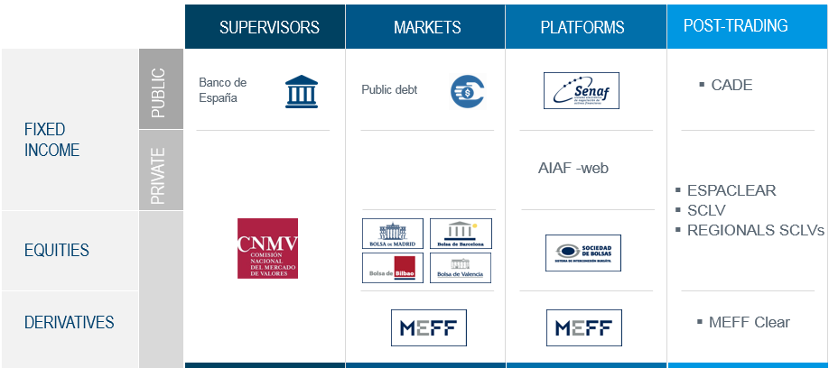
A summary of the main milestones is featured below:
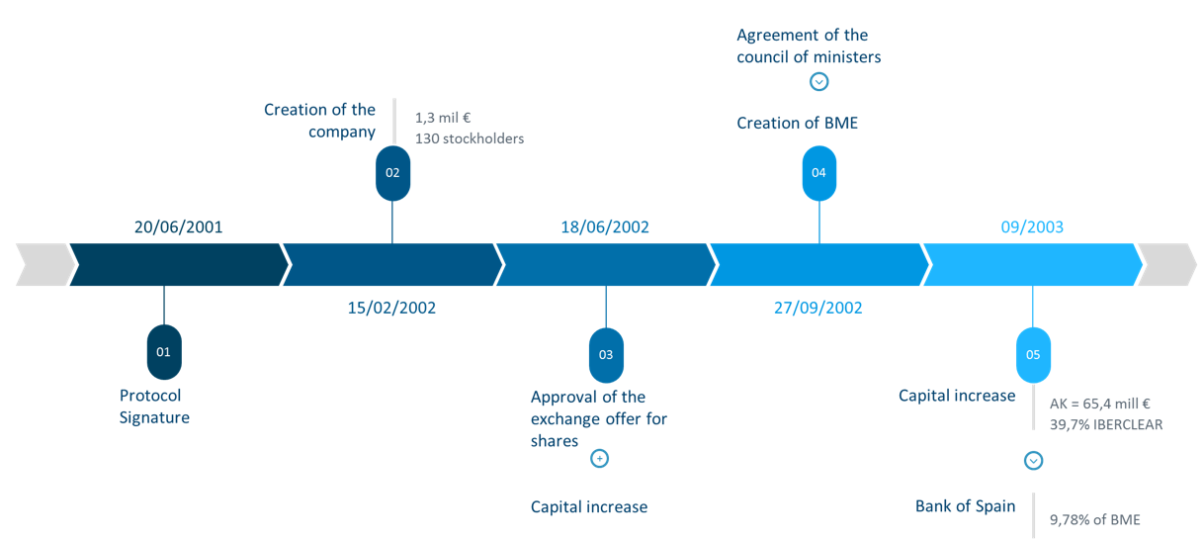
The first step to achieve the market integration was the signature of a Protocol for the Integration of Spanish Securities Markets the 20th June 2001. The signatory institutions of the agreement were the following: Sociedad Rectora de Bolsa de Madrid, Sociedad Rectora de Bolsa de Barcelona, Sociedad Rectora de Bolsa de Bilbao, Sociedad Rectora de Bolsa de Valencia, MEFF Holding de Productos Financieros Derivados, AIAF Mercado de Renta Fija, SENAF, Promotora para la Sociedad de Gestión de los Sistemas Españoles de Liquidación, IBERCLEAR and FC&M Sociedad Rectora de Mercado de Futuros y Opciones sobre Cítricos. The aim of the protocol was to create a Company that could respond to the changes in the environment in an efficient way.
In this context, the merger of the Spanish depositaries also took place: Servicio de Compensación y Liquidación de Valores (SCLV) and Central de Anotaciones del Banco de España (CADE). As a result IBERCLEAR was created.
The table below shows the result of the new structure.
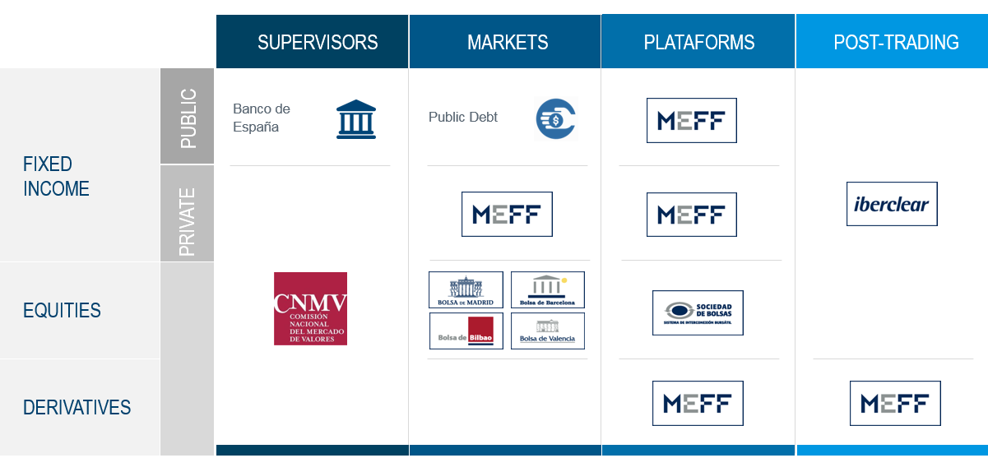
On December of the same year, the Spanish Exchange Regulation was modified, in order to allow the creation of a company that could buy the capital of all the firms that managed the register, clearing and settlement systems in Spanish secondary markets.
On February 2002, the new company was created. The new corporation brought together the four Spanish Stock Exchanges, the derivative and fixed income markets and clearing and settlement systems with an initial capital of 1, 3 million euros and 130 shareholders. Hereinafter, the exchange offer was approved, together with a capital increase 300,46 million Euros in order to meet up the exchange offer.
On September of the same year, the Council of Ministers approved the creation of BME.
On November 2002, the Board of Directors of the company approved the creation of the Company's governance Commissions: Executive Committee, Audit Committee, Remuneration Committee and Coordination Committee.
Finally, on September 2003, BME approved a capital increase of 65,4 million euros which allowed the company to integrate the 39,7 % of IBERCLEAR in the of Bank of Spain hands). As a consequence, Bank of Spain became a shareholder of BME, holding a 9,78 % of the company’s capital.
As a result of all this process, today, BME is the operator of all stock Markets and financial systems in Spain, managing the four Spanish Exchanges (Bolsa de Madrid, Barcelona, Bilbao and Valencia), the corporate fixed income market (AIAF), the derivatives market (MEFF), the Central Counterparty (BME Clearing), the Spanish central depository and clearing and settlement system (Iberclear), MTFs for public debt instruments (SENAF), Latin-American Stocks (LATIBEX) and SMEs securities (MAB and MARF).
The current structure is the following:
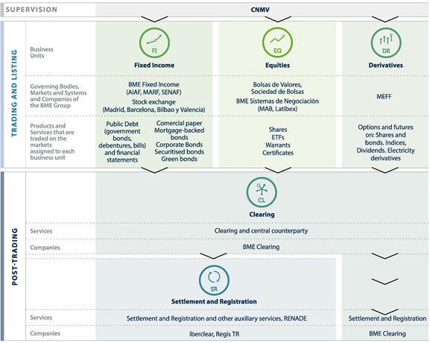

  - BME LISTING
BME’s securities offering and stock market listing was carried out by a public offering exclusively in the Spanish jurisdiction.
The offer was structured in two trenches: domestic (15,083,998 shares) and international (10.055.900 shares). The domestic trench was divided into three subgroups: retail, institutional and employees. The international trench was addressed to institutional investors.
The following table shows the main figures of the IPO:
Initial Public Offer
Nominal | 81,202,187,08 euros
Number of shares | 25,139,996 ( 30.07 % of capital).
 | Potential increase to 2,513,957 shares (3.01 % of capital)
Assignment procedure
Buy orders | June 30 to July 6, 2006
Price spread (non-binding) | 26,30 euros to 33.50 euros per share
Retail higher price setting | July 6, 2006 (33.50 euros per share)
Final buy orders | July 7 to 11, 2006
Assignment | July 11, 2006
Retail final price setting | July 12, 2006 (31 euros per share)
Final allocation | July 13, 2006
Admission to trading | July 14, 2006
Stabilization period | July 14 to August 11, 2006
Offering distribution
Domestic | 15,083,998 shares (60 % of IPO)
Retail | 7,501,999 shares (49.735 % of IPO)
Employees | 40,000 shares (0.265 % domestic offer)
Institutional | 7,541,999 shares (50,00 % domestic offer)
International | 10,055,998 shares (40 % of IPO)
Demand allocation
Domestic | 15,083,998 shares (60 % of IPO)
Retail | 7,501,999 shares (49.735 % domestic offer)
Employees | 56,424 shares (0.374 % domestic offer)
Institutional | 7,525,75 shares (49.89 % domestic offer)
International | 10,055,998 shares (40 % of IPO)
Following its admission to trading, during the first trading session 11,128,310 shares. The price moved between 29.62 and 30.78, closing at 29.75 euros per share.
  - BME’S STRUCTURE TODAY
Bolsas y Mercados Españoles (BME) integrates the whole value chain, operating all stock Markets and financial systems in Spain. The following chart shows BME´s current organization

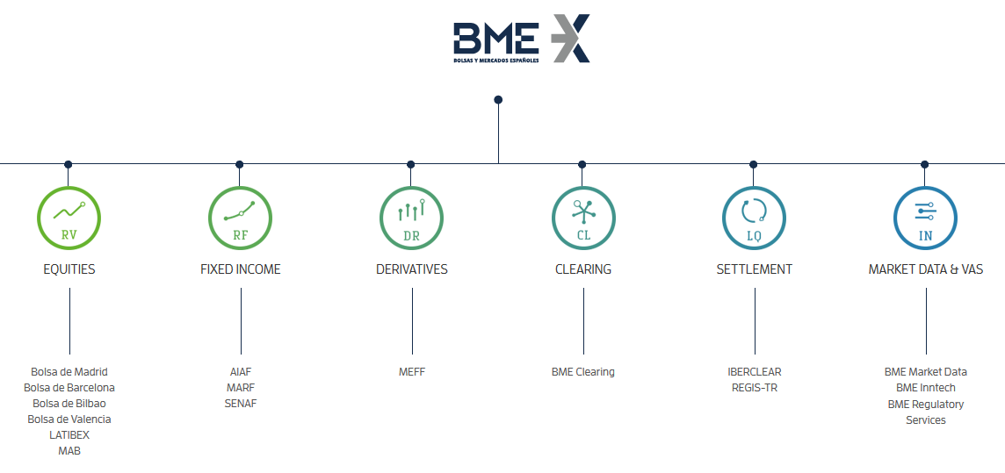
Regarding “market data and VAS”, it shall be pointed out that, BME INNTECH was created in 2017 as a result of the merger between BME Innova, Infobolsa and Visual Trader, following the principle that the whole is greater than the sum of the parts. The objective of the merger is to gain operating synergies and an increase in the value of the shareholders.
  - BME’S BUSINESS MODEL
BME business model is supported in five pillars that are directly related. BME believes in a fully integrated value chain based on in-house technology systems, focused on robustness, efficiency, and transparency, allowing to create a diversified business.
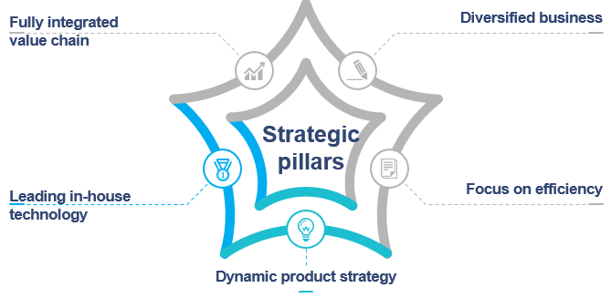
Fully integrated value chain
As it has been detailed in previous sections, BME is a vertical silos as it is a private company that covers the whole value chain:
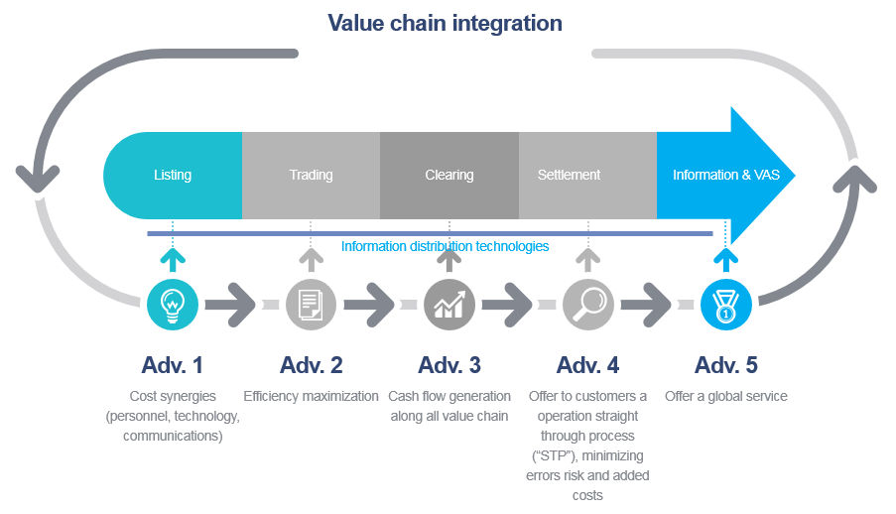
Diversified business
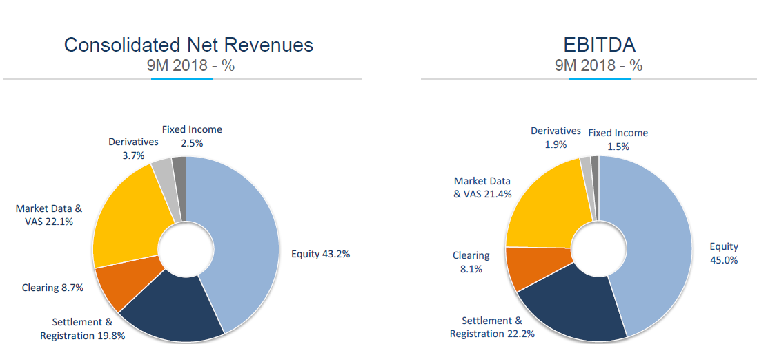
Bolsas y Mercados Españoles (BME) reported a net profit for the third quarter of 2018 of €30.2 million.
Focus on efficiency
BME is focused on efficiency, creating an optimal cost structure for its size. The monitoring and comparison with other companies in the sector in which the BME operates is performed through three indicators:
  - Efficiency ratio: measures the operating costs over total net revenue.
  - ROE: measures the return on equity.
  - RNLV: Ratio of revenues not linked to volumes over operating costs.
BME relevant ratios are among the best among their peers. This is one of the effects of vertical integration. The table below shows the evolution of the different indicators:
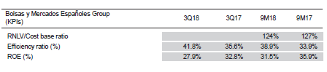
Leading in-house technology
BME has always believed in in-house development of trading platforms and systems. The main features of our platforms are the following:

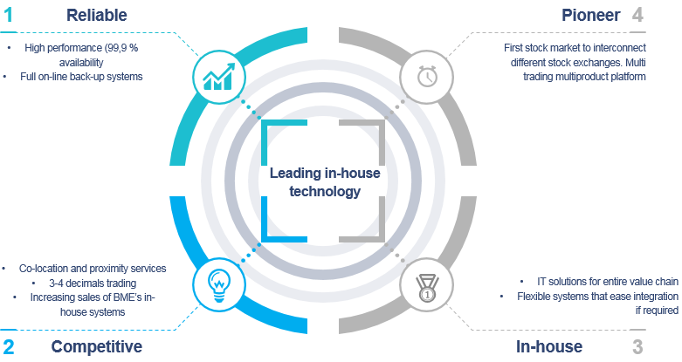
All value chain solutions have been in-housed developed by BME (trading, CCP, CSD, registry). Nowadays, this platforms are not only being used in Spain, but they have also been implemented internationally, mainly in Latin America and Africa. Additionally, BME offers solutions and services to all financial sector agents and players, as well as companies from other sectors, both nationally and internationally. The services offered cover a wide range, from compliance solutions (market abuse or reporting) to information services solutions.
Dynamic product strategy
BME has opted to take advantage of a dynamic product strategy, as it is shown in the following graphic:
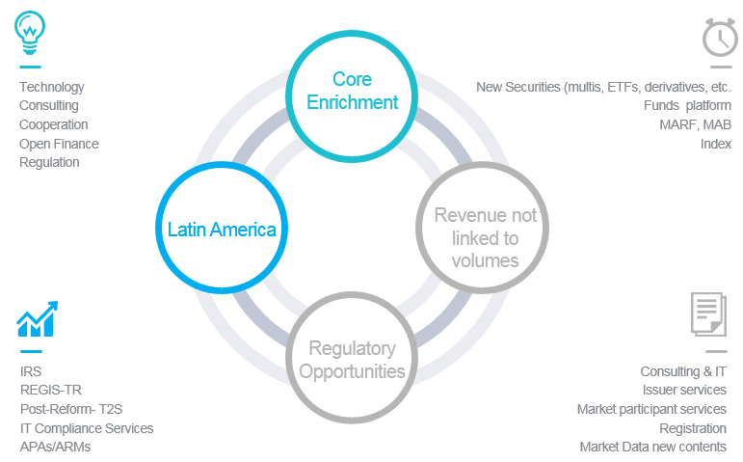
  - HOLDING ORGANIZATION
BME’s business and corporate areas are the following:

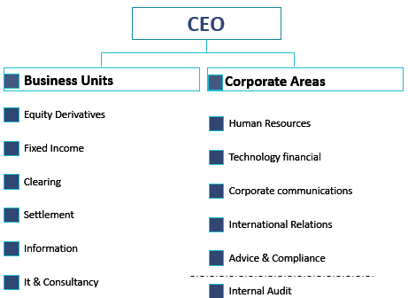

This issue is addressed in detail in section 1.1
This issue is addressed in detail in section 1.1
This issue is addressed in detail in section 1.1
As explained in 1.1 Capital requirements section
Following COMMISSION DELEGATED REGULATION (EU) 2017/ 1946 - of 11 July 2017 - supplementing Directives 2004/ 39/ EC and 2014/ 65/ EU of the European Parliament and of the Council with regard to regulatory technical standards for an exhaustive list of information to be included by proposed acquirers in the notification of a proposed acquisition of a qualifying holding in an investment firm.
Short term or temporary positions can be considered in the assessment but are usually not sufficient to support adequate expertise.
Guidelines on the management body of market operators and data reporting services providers.
Unless representing the State.
Latency is especially relevant when trading equities and derivatives.
150 kilometers has been used as a reference in general terms.
http://wdc.org.ua/en/node/193
https://uptimeinstitute.com/
https://journal.uptimeinstitute.com/explaining-uptime-institutes-tier-classification-system/
One camera per aisle is recommended
According to Art 2, a foreign issuer a legal entity established under laws of another country and issuing securities in Ukraine or a legal entity whose securities are registered in accordance with laws of another country and admitted by the NSSMC to trading in Ukraine.
Art 12 of UX Rule Book.
We believe the best option is to create a unique market for trading of foreign companies. Otherwise, if each current exchange has a segment for trading international companies, liquidity would be fragmented.
Specifically in issues as admission to trading, supervision and information dissemination.
These rules are applicable to the opening and closing auction as well as volatility auctions that are proposed in the continuous market model.
This systems are crucial in equities, but they are already gaining relevance in all asset classes.
Following our conference call, on this section we have focused on transparency regime for issuers, therefore, we have changed the initial name “Operational requirements for exchanges and other trading venues in other to improve price discovery process, through the establishment of an adequate transparency regime”.
Articles 70 to 86 of the Law.
Regulation (EU) 2017/1129 of the European Parliament and of the Council of 14 June 2017 on the prospectus to be published when securities are offered to the public or admitted to trading on a regulated market, and repealing Directive 2003/71/EC.
Articles 103 to 107.
Whereas (50) of Regulation (EU) No 596/2014 of the European Parliament and of the Council of 16 April 2014 on market abuse (market abuse regulation).
Public consultation review of the markets in financial instruments directive (MIFID) 2010-12-08
REGULATION (EU) No 600/2014 OF THE EUROPEAN PARLIAMENT AND OF THE COUNCIL of 15 May 2014 on markets in financial instruments and amending Regulation (EU) No 648/2012 (Text with EEA relevance).
Whereas 7 of Regulation (EU) No 596/2014 of the European Parliament and of the Council of 16 April 2014 on market abuse (market abuse regulation) and repealing Directive 2003/6/EC of the European Parliament and of the Council and Commission Directives 2003/124/EC, 2003/125/EC and 2004/72/EC (Text with EEA relevance)
Terms and conditions are described in the Offering Memorandum approved and registered on June 29, 2006 in the official register of the “Comisión Nacional del Mercado de Valores” (CNMV)
A table with more detail is provided in Annex II

